STUDY GUIDE

DEPARTMENT OF DERMATOLOGY

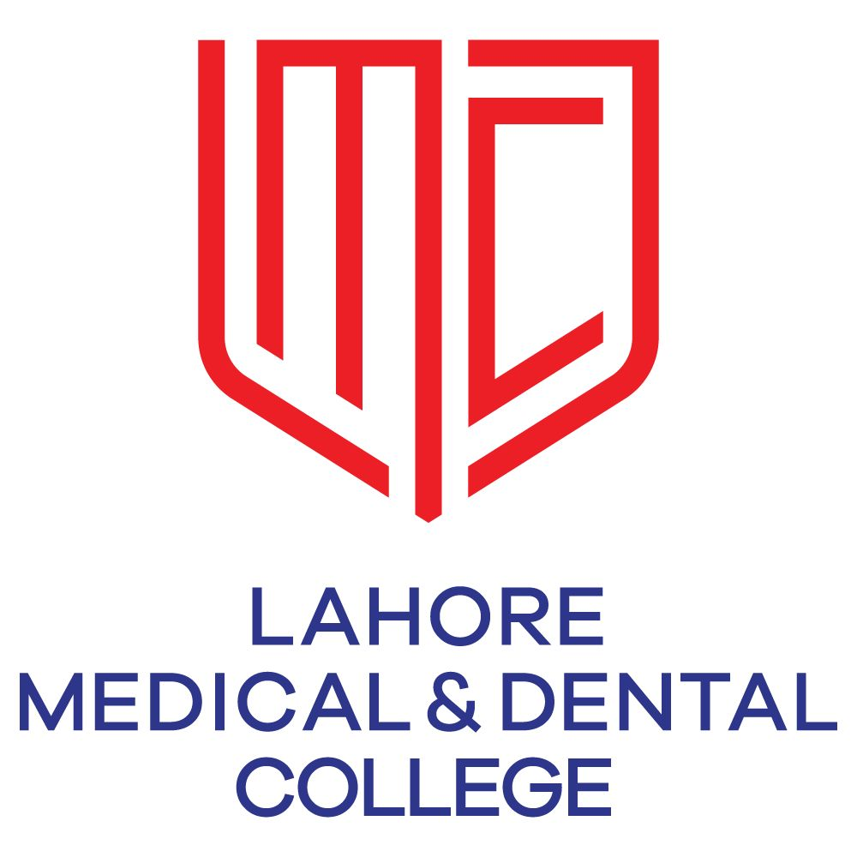

&

GHURKI TRUST TEACHING HOSPITAL

CONTENTS

- Introduction
- Learning Audience
- Purpose of Guide
- Learning Objectives
- Teaching & Learning Methodologies
- Content/Syllabus (PMDC)
- Departmental Faculty hierarchy
- Alignment of education with study hours (Final year MBBS)
- Learning Resources
- Assessments Methodology

INTRODUCTION
Medical education is a life-long process and MBBS curriculum is a part of the continuum of education from pre-medical education, MBBS, proceeding to house job, and post-graduation. PM&DC outlines the guiding principles for undergraduate medical curriculum and has defined the generic competencies and desired outcomes for a medical graduate to provide optimal health care, leading to better health outcomes for patients and societies. These generic competencies set the standards of care for all physicians and form a part of the identity of a doctor. Each competency describes a core ability of a competent physician. This study guide will give an insight to the students about all these competencies and how to plan their educational activities in the subject of surgery for the three years period.
LEARNING AUDIENCE
5th year MBBS students

PURPOSE OF GUIDE: To facilitate learning of the student by enlightening them about the organization of the learning program; to facilitate students in managing their studies through the academic year and guidance on assessments methods, exam rules and regulations

LEARNING OBJECTIVES (knowledge, skills, attitude)
- to equip the students with specific knowledge, essential skills and appropriate attitude towards the human body
- to become problem solvers, dealing effectively with familiar and unfamiliar problems
- to become lifelong learners
- to direct their own learning and evaluate this activity
- to be able to reason critically and make justifiable decisions regarding patient management
- to practice evidence-based medicine
- to always ensure patient safety
- to ensure compliance with the legal system as it impacts health care and the PM&DC regulations
- to adopt a multidisciplinary approach for health promoting interventions
- to enable medical graduates to demonstrate professional values of self and professional accountability, honesty, probity, and ethics
- to enable medical graduates to demonstrate exemplary professional conduct
- to be able to understand the pathogenesis of specific diseases
- to be able to take a focused history and identify the patient’s risk factors related to the disease process
- to be able to perform a physical examination on a patient, to diagnose specific dermatological diseases and differentiate from other systems
- to formulate a provisional diagnosis with justification, and the likely differential diagnoses
- to be able to select appropriate biochemical investigations and interpret their reports to confirm the diagnosis
- to be able to select specific radiological investigations for specific diseases
- to be able to apply evidence-based dermatology concepts for the dermatological treatment of different diseases

TEACHING AND LEARNING METHODOLOGIES FOR DERMATOLOGY
- Interactive Lectures
- Case based learning (CBL)
- Power point presentations by students
- Small group discussions
- Teaching of : use of magnifying glass, Wood’s Lamp, scraping for fungus, observe skin biopsy.
- Clinical ward rotations
- CPC’s – using modern audio-visual techniques, distant learning using electronic devices and current Information technology facilities
- Self-directed learning is the most vital part of this module to solve problematic cases, go through different learning resources and discuss with peers and the faculty to clarify difficult concepts

ATTENDANCE REQUIREMENT FOR DERMATOLOGY
- Students are expected to attend all scheduled teaching sessions and examinations
- Attendance in lectures, tutorials, and wards is mandatory. Absence from these sessions will make the students ineligible to sit the final summative assessment.
- A minimum of 75 % attendance in the lectures, wards is mandatory to appear in the summative UHS examination
- Attendance will be recorded through a log-in/log-out biometrics system
- Absence due to illness must be certified appropriately by the General Physician

COURSE CONTENT TO BE STUDIED (syllabus) PMDC
The course outline is as follows :
Dermatology
Lectures, Seminars, Tutorials, etc. The respective teachers in the speciality will be responsible for teaching the suggested list of topics as under

- Anatomy, Physiology of skin related to clinical Dermatology.
- Infestations: Scabies, Pediculosis
- Bacterial and Mycobacterial Infections
- Fungal and viral diseases.
- Acne Vulgaris
- Eczemas
- Psoriasis and Lichen Planus
- Bullous Disorders
- Pigmentary Disorders
- Disorders of Nails
- Disorders of hairs.
- Sexually Transmitted Diseases.

Clinical Teaching:

i. Student should be able to recognize lesions of:
• Scabies
• Pediculosis
• Mosquito bite
• Tinea (Corporis, Capitis, Inguinale, Unguam)
• Candida (Oral, Skin)
• Acute & Chronic Eczema
• Lesions of Small Pox, Chicken Pox, Herpes Simplex, Herpes Zoster
• Pityriasis versicolor
• Furunculosis, cellulitis
• Psoriasis
• Lichen Planus
• Impetigo Contagiosum
• Molluscum Contagiosum
• Acne Vulgaris
• Seborrhoea
• Exfoliative Dermatitis
• Skin Neoplasm like Squamous cell cacinoma, basal cell carcinoma and melanoma
• Leukoderma
.SLE
• Alopecia and Hirsutism
• Sexually transmitted diseases
• Leprosy
• Syphilitic lesions (Chancre, Secondary Syphilis, Gumma)
• Drug Eruption
ii. Procedures:
- Use of Magnifying glass
- Use of Wood's Lamp
- Scraping for fungus
- Observe skin biopsy

DEPARTMENTAL FACULTY HIERARCHY

Dermatology department teaching staff consists of :

  - Prof. Haroon Nabi (Head of Department)
  - Dr. Talat Masood Akbar (Associate Professor)
  - Dr. Gulnaz Ali (Senior Registrar)
ALIGNMENT OF EDUCATION WITH STUDY HOURS
(5th year MBBS )
Sr # | Topic | Tutor | Lectures | Study hours
1 | Introduction to Skin, Anatomy of Epidermis, Dermis, Specialized structures, functions & types of Skin Lesions. | Prof. Dr. Haroon Nabi | 1 | 45 minutes
2 | D.Dx of Itching, Pruritus, Infestations: Scabies, Pediculosis, Urticaria & Insect Bite. | Prof. Dr. Haroon Nabi | 1 | 45 minutes
3 | Eczemas: Atopic Dermatitis, Seborrhoeic Dermatitis & Contact Dermatitis | Prof. Dr. Haroon Nabi | 1 | 45 minutes
4 | Erythemato-Squamous Disorders:  Psoriasis, Erythroderma, Lichen Planus. | Dr. Talat Masood Akbar  ( Associate Professor) | 2 | 1.5 hours
5 | Acne Vulgaris | Dr. Talat Masood Akbar  ( Associate Professor) | 1 | 45 minutes
6 | Bullous Eruptions : Pemphigus, Pemphigoid, Dermatitis Herpetiformis. | Dr. Talat Masood Akbar  ( Associate Professor) | 2 | 1.5 hours
7 | Erythema Multiforme,  SJS / TEN. Drug Reactions. | Dr. Talat Masood Akbar  ( Associate Professor) | 1 | 45 minutes
8 | Infections: Viral, Fungal, Bacterial: furunculosis, Cellulitis.  Leprosy, T. B | Prof. Dr. Haroon Nabi | 3 | 2 hours 15 minutes
9 | Disorders of hair:  Alopecia, Hirsutism  Disorders of Nails. | Prof. Dr. Haroon Nabi | 2 | 1.5 hours
10 | Sexually Transmitted Diseases. | Prof. Dr. Haroon Nabi | 1 | 45 minutes
11 | Cutaneous Manifestations of Systemic Diseases | Prof. Dr. Haroon Nabi | 1 | 45 minutes
12 | Pigmentary Disorders | Prof. Dr. Haroon Nabi | 1 | 45 minutes

LEARNING RESOURCES
Recommended books
- ABC OF DERMATOLOGY BY DR. TAHIR SAEED HAROON.
- DAVIDSON'S PRINCIPLES AND PRACTICE OF MEDICINE 22ND EDITION.
- Oxford Handbook of Dermatology by Dinny Wallis and Susan Burge.
- FITZPATRICK'S Color Atlas and Synopsis of Clinical Dermatology, Seventh Edition.

Technologies to be used
- Textbooks are the most important part of student learning for this subject
- Hands-on activities and practical sessions to enhance the learning.
- Videos from different web portals to familiarize the students with the procedures and protocols.
- Computer and Internet resources are essential to gather the latest information about a specific disease.

ASSESSMENT METHODOLOGY
Formative
Theory, 10 single best multiple choice questions, 4 short essay questions test at the end of session.
Clinical ward test, comprising of 25% marks for assignment, 25% for attendance, 50% for written and short cases.

Summative UHS examination (to be held at the end of 5th year MBBS)

Medicine Theory Paper II: 8 McQs , 1 SEQs & 1 OSCE station for Dermatology.
Summative examination details

5th Year MBBS, Medicine Paper II





