STUDY GUIDE FOR OBSTETRICS AND GYNAECOLOGY FOR MBBS STUDENTS

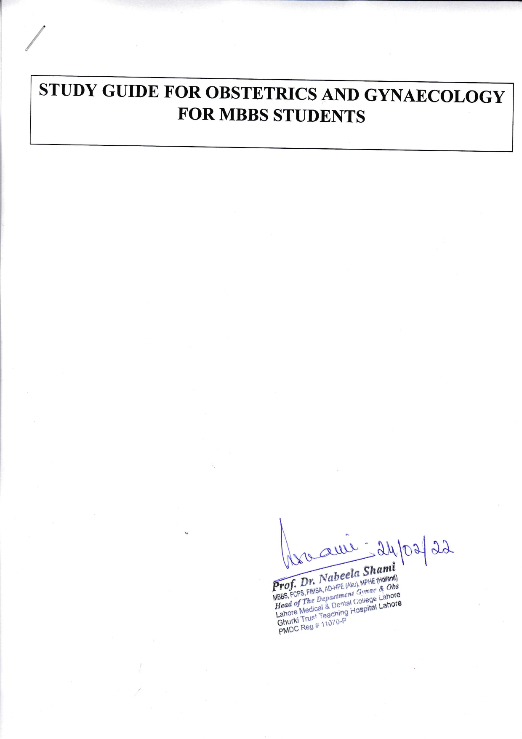
INTRODUCTION
Medical education consists of basic medical education, postgraduate medical education, and continuing professional development. Medical education is a dynamic process that commences with basic medical education under the guiding principles of PMC and continues until a physician retires from active practice. Its goal is to prepare physicians to apply the latest scientific knowledge to promote health, prevent and cure human disease and mitigate symptoms. It is to ensure that medical students have acquired the knowledge, skills, and professional behaviors that prepare them for a spectrum of career choices, including, but not limited to, patient care, public health, clinical or basic research, leadership, management and medical education. The cognitive skills of self-directed learning, critical thinking, and medical problem solving should be introduced early in the medical curriculum to prepare students for clinical training. This study guide will give an insight to the students about all these competencies and how to plan their educational activities in the subject of Obstetrics & Gynaecology for the two years period.
TARGET AUDIENCE
2nd, 4TH and 5th year MBBS students

DURATION OF COURSE
Total hours 301 allocated in three years.
(27 hours in 3rd Year + 72 hours in 4th year + 202 hours in 5th year)

LEARNING OBJECTIVES (knowledge, skills, attitude)
- To equip the students with specific knowledge, essential skills and appropriate attitude towards the human body
- To become problem solvers, dealing effectively with familiar and unfamiliar problems
- To become lifelong learners
- To direct their own learning and evaluate this activity
- To be able to reason critically and make justifiable decisions regarding patient management
- To practice evidence-based medicine
- To ensure patient safety
- To ensure compliance with the legal system as it impacts health care and the PM&DC regulations
- To adopt a multidisciplinary approach for health promoting interventions
- Medical graduates should be able to demonstrate professional values of self and professional accountability, honesty, probity, and ethics
- Medical graduates are expected to demonstrate exemplary professional conduct
- To be able to understand the pathogenesis of specific obstetric and gynaecological diseases
- To be able to take a focused history and identify the patient’s risk factors related to the obstetric and gynaecological disease process
- To be able to perform a physical examination on a patient, to diagnose specific obstetric and gynaecological diseases.
- To formulate a provisional diagnosis with justification, and the likely differential diagnoses
- To be able to select appropriate biochemical investigations and interpret their reports to confirm the diagnosis
- To be able to select specific radiological investigations for specific obstetric and gynaecological diseases
- To be able to apply evidence-based medicine concepts for the treatment of obstetric and gynaecological diseases
- To be able to describe the required operative procedures for different obstetric and gynaecological disease process

TEACHING METHODOLOGIES
- Interactive Lectures
- Tutorials
- Essential Skills to be learned in the skills lab
- Teaching of surgical procedures in Operation theatres
- Clinical ward rotations / bedside teaching
- CPC’s – using modern audio-visual techniques, distant learning using electronic devices and current Information technology facilities
- Maternity ward duties
- Self-directed learning is the most vital part to solve problematic cases, go through different learning resources and discuss with peers and the faculty to clarify difficult concepts

ATTENDANCE REQUIREMENT
- Students are expected to attend all scheduled teaching sessions and examinations
- Attendance in lectures, tutorials, and wards is mandatory. Absence from these sessions will make the students ineligible to sit the final summative assessment.
- A minimum of 90 % attendance in the lectures, wards is mandatory to appear in the summative UHS examination
- Absence due to illness must be certified appropriately by the General Physician

SYLLABUS (OBSTETRICS)
1. Introduction.
2. Obstetric history taking and examination.
3. Conception, implantation and development of placenta,
fetal circulation, abnormalities of placenta.
4. Foetal skull and bony pelvis.
5. Diagnosis of pregnancy.
6. Physiological changes associated with pregnancy.
7. Ante-natal care.
8. Physiology of labour.
9. Mechanism of labour.
10. Management of labour.
11. Complications of 3rd stage of labour.
12. Abnormal labour e.g. Prolonged labour/obstructed labour.
13. Pre-term labour.
14. Induction of labour.
15. Pre-maturity.
16. Post-maturity.
17. Conduction of normal delivery.
18. Operation delivery.
19. Forceps delivery.
20. Vacuum delivery.
21. Caesarean section.
22. Ante-partum haemorrhage.
23. Hydramnios.
24. Hyperemisis gravidarum.
25. Medical Disorder associated with pregnancy e.g.
- Pregnancy with anaemia
- Pregnancy with heart disease
- Pregnancy with diabetes
26. Hypertensive disorders of pregnancy e.g.
- PET
- Eclampsia
- Essential hypertension
27. Obstetric shock.
28. Intra uterine growth retardation and its management.
29. Fetal distress and its management.
30. Fetal Monitoring.
31. Fetal presentations.
32. Breech presentation.
33. Occipito posterior position.
34. Brow presentation.
35. Face presentation.
36. Cord prolapse/compound presentation.
37. Transvese lie/unstable lie.
38. Multiple pregnancy.
39. Puerperium (normal and abnormal).
40. Examination of the new-born baby.
41. Resuscitation of new-born.
42. Minor problems of the new-born.
43. Breast feeding and its importance.
44. Obstetric injuries/ruptured uterus.
45. Haematological disorder of pregnancy e.g.
- Rh incompatibility
- Thalassemia major/minor
Practical:
Log Book of 20 assisted deliveries.
RECOMMENDED BOOKS:
- Obstetrics by Ten Teachers by Louise C. Kenny & Jenny E Myers. 20th edition, 2017.
- Hacker & Moore’s Essentials of Obstetrics and Gynecology by Neville F. Hacker, Joseph C. Gambone, Calvin J, Hobel, 6th ed. 2015.
- Notes on Obstetrics & Gynecology. Stirrat, Mills, Draycott. 5th Ed. 2003.
- Fundamentals of Obstetrics by Arshad Chohan, 2021.
- Online Journals and Reading Materials through HEC Digital Library Facility.

SYLLABUS (GYNAECOLOGY)

The course outline is as follows:
1. Introduction.
2. Anatomy of female
i. Genital organs
ii. Development of female genital organs
3. Puberty and adolescence.
4. Ovulation and its clinical importance.
5. Normal menstruation.
6. Menstrual abnormalities.
7. Gynaecological history taking and examination
8. Amenorrhoea
9. Infertility.
10. Contraception.
11. Ectopic pregnancy.
12. Bleeding in early pregnancy
- Miscarriage
- Ectopic
- Molar Pregnancy
13. Trophoblastic tumours.
14. Vulval lesion.
15. Tumours of cervix.
16. Tumours of uterus.
17. Tumours of ovaries.
18. Menopause, Hormone replacement therapy.
19. Genital prolapse.
20. Pelvic floor injuries.
21. Urogynaecology.
22. Problems of marriage and sex.
23. Vaginal discharges.
24. Infections of female genital tract
i. Infections of upper genital tract
ii. Infections of lower genital tract
25. Endometriosis
Practical:
Log Book of 20 patients of Gynaecology.

RECOMMENDED BOOKS:
- Gynaecology by Ten Teachers, by Stanley G. Clayton and Ash Monga, 20th Edition
- Hacker & Moore’s Essentials of Obstetrics and Gynecology by Neville F. Hacker, Joseph C. Gambone, Calvin J, Hobel, 6th edition. 2015.
- Notes on Obstetrics & Gynecology by Stirrat, Mills, Draycott. 5th Ed. 2003.
- Text book of Gynecology by Rashid Latif, 7th Edition, 2012.
- Fundamentals of Gynecology by Arshad Chohan, 2022, international edition.
- Online Journals and Reading Materials through HEC Digital Library Facility.
3rd Year Teaching planner
Clinical Ward’s Rotation = 27 hours

4th year shared lectures topics
- Reproductive Health
- Sexually transmitted diseases
- Antenatal care
- Contraception
Duration of each lecture = 45 min (0.75 hour)
Total duration of lectures = 27 Hours (0.75 hr *36 weeks)
Clinical Ward rotation = 45 hours (4 days /week)
Total hours in 4th year = 27+45= 72 hours

Sr. No. | Number of lectures | Chapter | Topics
 | Lecture 1  4th year | Introduction to Obstetrics | Definitions  Gravidity, parity  Obstetric examination  Symptoms of pregnancy
 | Lecture 2,3  4th year | Physiological changes in pregnancy | Effects of pregnancy on the cardiovascular, respiratory, genito-urinary systems
 | Lecture 4  4th year | Antenatal care | Frequency of antenatal visits  Common antenatal problems
 | Lecture 5  4th year | Normal fetal development and growth | Fetal growth in different trimesters, fetal circulation, amniotic fluid production
 | Lecture 6  4th year | Assessment of fetal wellbeing | Introduction  CTG  Ultrasound  Biophysical profile
 | Lecture 7  4th year | Abnormalities of amniotic fluid | Oligohydramnios  Polyhydramnios  Management
 | Lecture 8  4th year | Care of newborn | APGAR score  Examination of newborn baby  Resuscitation of newborn baby  Common neonatal problems  Management
 | Lecture 9  4th year | Multiple pregnancy | Types  Complications  Management
 | Lecture 10  4th year | Introduction | Anatomy of female  i. Genital organs  ii. Development of female genital organs
 | Lecture 11  4th year | Puberty and adolescence  Ovulation and its clinical importance | Introduction  Puberty and secondary sexual development
 | Lecture 12  4th year | Normal menstruation | Physiology of menstruation
 | Lecture 13  4th year | Infertility | Introduction  Natural conception  Causes of infertility  History and examination
 | Lecture 14,15  4th year | Contraception | Introduction  Methods of contraception
 | Lecture 16,17  4th year | Infections of female genital tract | Infections of upper genital tract  ii. Infections of lower genital tract
 | Lecture 18,19,20  4th year | Labor | Mechanism of normal labor  Stages of labor  Management of labor
 | Lecture 21  4th year | Abnormal labor | Prolonged labor  Obstructed labor
 | Lecture 22  4th year | Fetal malpresentations/  Malpositions | Brow presentation  Face presentation  Occipitoposterior
 | Lecture 23  4th year | Breech | Types, labor management, ECV
 | Lecture 24  4th year | Operative delivery | Cesarean section  Indications/procedure/  complications
 | Lecture 25  4th year | Instrumental delivery | Forceps delivery  Ventouse delivery  Complications
 | Lecture 26  4th year | Induction of labour | Indications  Methods

5th Teaching planner
Duration of each lecture = 45 min (0.75 hour)
Total duration of lectures = 54 Hours (1.5 hr * 36 weeks)
Clinical Ward morning = 120 hours (5 days /week for 6 weeks)
Clinical Ward Maternity Duty of 7 days duration = 4 hr X 7 days = 28 hours
Total hours in 5th year = 54+120+28 = 202 hours
Sr.No | Number of lecture | Chapter | Topics
 | Lecture 1  5th year | Postpartum hemorrhage | Resuscitation and specific management
 | Lecture 2,3  5th year | Anemia in pregnancy | Introduction  Types of anaemia  Iron deficiency anaemia  Thalassemia  Management
 | Lecture 4,5  5th year | Diabetes in pregnancy | Introduction  Types  Diagnosis  Complications  Management
 | Lecture 6,7  5th year | Hypertensive disorders in pregnancy | Introduction  Types  Etiology  Management  Eclampsia
 | Lecture 8  5th year | Cardiac diseases in pregnancy | Common cardiac conditions  Management
 | Lecture 9,10  5th year | Antepartum haemorrhage | Introduction  Etiology(Placenta previa, placental abruption  Management
 | Lecture 11  5th year | Assessment
 | Lecture 12  5th year | Obstetric emergencies | Cord prolapse/uterine inversion, shoulder dystocia,maternal collapse
 | Lecture 13  5th year | IUGR | Causes  Management
 | Lecture 14  5th year | Preterm labor | Diagnosis  Tocolysis  Management
 | Lecture 15  5th year | Post term labor | Introduction  Complications  Induction of labor
 | Lecture 16  5th year | Rh-incompatibility | Pathophysiology  Management
 | Lecture 17  5th year | Puerperium | Changes in puerperium  Importance and management of lactation, Common infections in puerperium,sepsis
 | Lecture 18,19  5th year | Amenorrhoea  Primary  Secondary | Definitions and types  Causes  Investigations  Treatment
 | Lecture 20,21  5th year | Disorders of menstruation | Definitions  and their management
 | Lecture 22  5th year | Assessment
 | Lecture 23  (5th year) | Infertility | Introduction  Investigations  Management
 | Lecture 24  5th year | Ectopic pregnancy | Introduction  Aetiology  Management
 | Lecture 25  5th year | Miscarriage | Introduction  Types  Causes  Management
 | Lecture 26  5th year | Gestational trophoblastic neoplasia | Introduction  Types( benign and malignant variants)  Management
 | Lecture 27,28  5th year | Tumours of cervix | Premalignant disease of the cervix  Malignant disease of the cervix  Staging  Management  Cervical screening
 | Lecture 29,30  5th year | Tumours of uterus | Classification of endometrial cancers  Staging  management
 | Lecture 31,32  5th year | Tumours of ovaries | Classification  FIGO Staging  Management  Adjuvant treatment
 | Lecture 33  5th year | Vulval lesions | Benign and malignant lesions  Management
 | Lecture 34  5th year | Menopause, Hormone replacement therapy | Definitions  Physiological menopause  Non-physiological menopause  Effects and their management
 | Lecture 35  5th year | Pelvic organ prolapse | Introduction  Supports of uterus  Degrees of prolapse  Treatment
 | Lecture 36  5th year | Urinary incontinence | Types and management
 | Lecture 37,38  5th year | Endometriosis | Introduction  Management
 | Lecture 39  5th year | Fibroid uterus | Pathology/Management
 | Lecture 40  5th Year | Assessment

Feedback is taken from the Students about program evaluation
Total Number of Hours
3rd year = 27 hours
4th year = 72 hours
Final Year = 202 hours
Total = 27+72+202 = 301 hours

INTERNAL ASSESSMENT Marks: 30
It includes Class tests, Ward test, Send-up examination result and attendance.
ASSESSMENT METHODOLOGY
Formative
Theory, single best multiple choice question test at the end of each topic finished
Clinical ward test, comprising of 25 marks and percentage is shown on card.
Summative UHS examination (to be held at the end of 5th year MBBS)
Theory Paper I: Obstetrics
Theory Paper II: Gynaecology Summative examination details
Paper -1, Obstetrics = 70 marks, 7 seq= 35 marks, 35 Single best answer multiple choice questions= 35
Total = 70 marks
Paper- 2, Gynae = 65 marks, 10 seq= 30 marks, 35 Single best answer multiple choice questions= 35 Total = 65 marks
Internal assessment=15 marks
Total of theory= 150 marks
Clinical and practical exams
OSCE= 75 marks, 15 stations, 8 obstetrics (5 static and 3 interactive) and 7 Gynaecology (5 static and 2 interactive)
Long case obstetrics= 30 marks
Long case Gynaecology= 30 marks
Internal assessment= 15 marks
Total of viva = 150 marks
Total marks of theory and viva =150+150 = 300 marks

