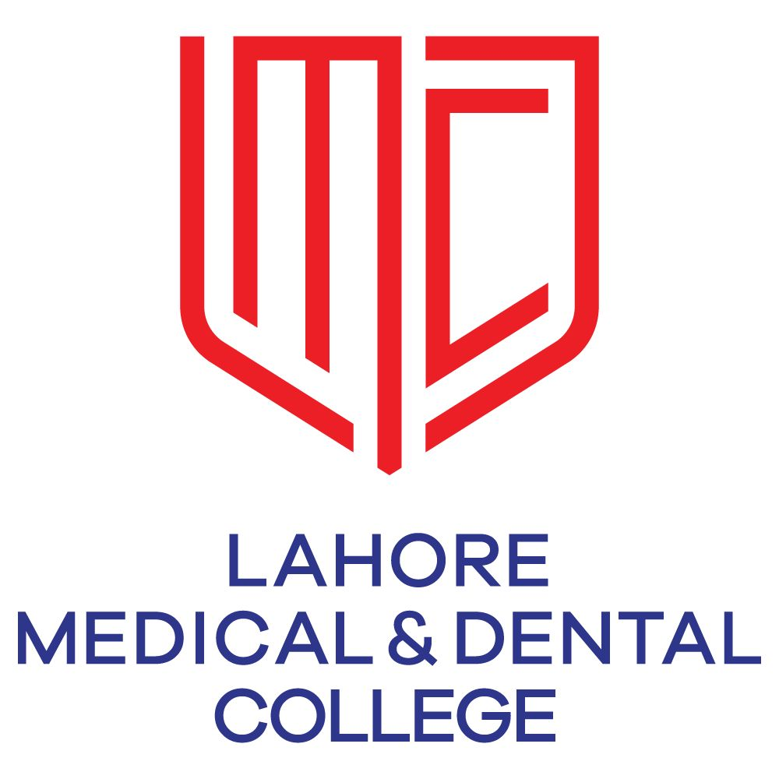
Lahore Medical & Dental College, Lahore
Department of Pharmacology
Study Guide
For
PHARMACOLOGY
(3rd Year MBBS)

Contents:-
Sr. # | Contents | Page. No
1 | Introduction | 03
2 | Learning Objects | 04
3 | Syllabus (PMDC) | 05
4 | Teaching & Learning Methodology | 08
5 | On-Line Teaching Methodology | 09
6 | Attendance Required | 10
7 | Learning Resources | 11
8 | Assessments Methods | 12
9 | Exam Rules and Regulation | 13
10 | Planner | 16
11 | Timetable | 17
12 | Pharmacology Study Hours | 18
13 | Curriculum Map) 3rd year MBBS | 19
14 | Organogram of Pharmacology | 20

- Introduction:-

It is the science that deals with the origin, nature, chemistry, effects, and uses of drugs. It includes pharmacognosy, pharmacokinetics, pharmacodynamics, pharmacotherapeutics and toxicology.

Teaching in Year

3rd Year M.B.B.S

Duration of Course

One Year

- Learning Objectives: -

MBBS student, at the end of one year training in Pharmacology, is expected to:

- Understand pharmacokinetic and pharmacodynamic principles involved in the use of drugs
- Understand and identify the various factors that can affect the action of drugs
- Know the various routes of drug administration with advantages and disadvantages of the various routes
- Undertake dosage calculations as appropriate for the patient and be able to select the proper drug and dose for the at risk population i.e. patients with kidney or liver disease, elderly, pregnant and lactating females, and children.
- Understand the importance of rational prescribing of drugs and the concept of essential drugs
- To be able to identify and monitor adverse drug reactions (ADRs) and appreciate the importance of ADR reporting
- Know the drugs used in systemic illnesses, infections and chemotherapy etc. with main mechanism(s) of action, pharmacokinetics, uses, side-effects and indications
- Understand the principles and practice of pharmacy
- Understand the methods in experimental pharmacology, principles of bioassay and be able to correlate drug effects with the action of drugs at the receptors.
- Have knowledge of common drugs and doses used for different ailments
- Have an understanding of basic mechanism by which a drug acts
- Should be able to select rationally from the available drugs

- Syllabus (PMDC)
Topic

General Pharmacology

Introduction

Routes of Administration
Transport across cell membrane
Absorption+ Bioavailability
Distribution
Biotransformation

Excretion, 1/2 Life, Kinetics

Pharmacodynamics
Dose response curve + Therapeutic Index
Drug allergy & Adverse effects
Drug dependence, addiction
Posology
Pharmacogenetics
Bioassay & Standardization
Locally acting drugs & Chelating agents
Disinfectants & Antiseptics + Phenol Chemo

Autonomic Nervous System
Introduction
Cholinergic Drugs
Anticholinergic Drugs
Muscle Relaxants
Ganglion Blockers
Catecholamines
Non-Catecholeamines
Beta Blockers
Alpha Blockers
Adrenergic Neuron Blockers
Ergot Alkaloids & Bromocryptine

GIT Drugs
Bitters & Sialogogues
Emetics & Anti emetics
Purgatives & Laxatives
Treatment of P.U & Antacids
Anti diarrheals & Bacillaryt Dysentry

Respiratory System Drugs
Mucolytics, Expectorants & Antitussives
Bronchodilators & Treatment of Asthma

Cardiovascular System Drugs
Vasodilators: Direct & Ca⁺⁺ Channel Blockers
Antihypertensive drugs & Treatment of Hypertension
ACE Inhibitors
Antianginal Drugs
Treatment of CCF
Anti arrythmic Drugs
Diuretics

DRUGS ACTING ON BLOOD
Antihyperlipidemic Drugs
Coagulants, Anti coagulants & Thrombolytic agents
Anti Platelets
Treatment of Anemia (Vitamins & Iron)

Autocoids:-
Histamine & Anti histamine
Prostaglandins & Serotonins

Drugs acting on CNS
Introduction
General Anesthetics
Local Anesthetics
Anti-Psychotic drugs
Antidepressants
Antimaniacs
Anti Parkinsonian Drugs
Sedative & Hypnotics + Anti-anxiety Drugs
Alcohol & Drug abuse
Trea arcotic Analgesics
Non-narcotic Analgesics
Treatment of Rheumatoid arthritis
Treatment of Epilepsy
CNS Stimulants & Xanthines
Treatment of gout
.

Drugs acting on Endocrine System
Pituitary hormones& Parathyroid drugs
Anti-thyroid
Corticosteroids
Antidiabetic Drugs(Insulin, Oral Hypoglycemic)
Sex Hormones, Contraceptives & Drugs for fertility
Drugs acting on uterus

Therapeutics
Antibiotics: Introduction
Cell wall synthesis inhibitors
Penicillins & Cephalosporins
Bacitracin, Vancomycin, Monobactam,
carbapenems,aztreonam

Protein Synthesis Inhibitors
Aminoglycosides Macrolides
Tetracyclines & Chloramphenicol

Antifolates Drugs
Sulphonamides & Cotrimoxazole+
Trimethoprine and Pyrimethamine

DNA Synthesis Inhibitors
Urinary Antiseptics & Quinolone derivatives
Anti-Cancer Drugs
Anti-Viral Drugs
Antifungal Drugs
Anti TB & Leprosy drugs
Antimalarial
Anti-amoebic Drugs
Anthelmintics

Miscellaneous Topics
Treatment of Edema, Shock, & plasma Expanders
Immuno modulators & Anti-D
Drug Interactions

PRACTICALS
A) Experimental pharmacology exercise on isolated organ - Assay of various drugs using rabbit ileum - Identification of unknown drugs by evaluating its action antagonism and drug interaction on rabbit ileum - Determination of concentration of unknown drug solution by different methods
B) Experimental exercise on pharmacy - General principles of pharmacy - Prescription writing exercises - Preparation and dispensing of powders, emulsions ointments, mixtures, liniments, suppositories and syrups
C) Spotting exercise - Identify the commonly used items in Pharmacology
D) Exercises on drug interactions

- Teaching & Learning Methodologies

- Interactive Lectures
- Tutorials
- Practicals
- Small Group Discussions
- Batch Wise Viva Voce
- Monthly bases tests (MCQ’s and SEQ’s)
- CME
- Long Tutorial Sessions
- Topic Wise Practice Test
- Using Latest Techniques of electronic facilities like Audio Visual and Multimedia
- Recommended E. Books

- On- Line Teaching Methodology
We use latest technologies, high speed internet and software for on-line coaching/ teaching.
- On-Line Classes / Lectures
We deliver on-line classes/ Lectures on google meet, Microsoft teams and google class room
- On- Line Tutorials Classes
We conduct on-line tutorial classes on google meet, Microsoft teams and google class room
- On- Line Practical Classes
We arrange on-line practical classes on google meet, Microsoft teams and google class room
- On- Line Assignments
On-line Assignments on google meet, Microsoft teams and google class room
- On- Line Test Conducting
We conduct on-line tests on class room (Google forms)
- On- Line Notifications
On-line notifications on google calender, Microsoft teams and lmdc web portal

- Attendance Required

- 75% Attendance is mandatory in (Lectures, Practical and Tutorials)

- A minimum 75% Attendance is required for eligibility to appear in Annual Examination according to University of Health Sciences, Lahore

- Attendance will be marked through the Bio- Metric Attendance Systems (thumb Impression) and also record in Attendance Registers.

- Absences due to Sickness/ Illness must be certified by a Medical Officer and approved by Principal and Head of Department also.

- Learning Resources
Recommended Books:-
- Goodman & Gilman’s - The Pharmacological Basis of Therapeutics
- Basic & Clinical Pharmacology by Bertram G, Katzung
- Clinical Pharmacology by DR Lawrence, PN Bennett & MJ Brown
- Essentials of Medical Pharmacology by K.D. Tripathi
- Lippincott Illustrated Review Pharmacology

- Technologies to be Used:-
- Text Books are the Most Important source to learn for this Subject
- Hand Outs (by Senior Faculty Members)
- E. Books (Available)
- Multimedia (Power Point)
- Tables of Drugs Chart
- Discussions
- Viva Voce type Practice
- Departmental Library

- Assessments Methods

Formative:-

- MCQ’s and SEQ’s type Test will be held at the end of the every topic.
- Viva Voce will be held at the end of every major topic.
- Assignments given, checked and marked for 10 marks
- Summer Vacation work (assignments type)
- Arrange CME’s to build and improve their knowledge and skills

- Exam Rules and Regulation
Examination will be held at the end of the academic session.
Marks Distribution Scheme According to University of Health Sciences Rules and Regulation:-

Total Marks of the subject in Professional examination----300 Marks
Theory Examination:
- 65 Multiple Choice Questions (1 Mark for Each Question) --------65 Marks
- 10 short Essay Questions (7 marks for Each Question) ---------70 Marks
- Internal Assessment ----------15 Marks
Total Marks 150 Marks
Oral//Practical & Viva Voce Examination:
Viva Voce Examination:
- Viva Voce will be held after Theory Examination
- Viva Voce (Internal Examiner): 30 Marks and 05 Marks for Note Book---35 Marks
- Viva Voce (External Examiner): ----30 Marks
OSPE Examination:-
- 07 Observed and non-Observed Stations (Each Station having 05 Marks)---35 Marks
- Experimental Pharmacology: ----20 Marks
- Pharmacy Practical: -----15 Marks
- Internal Assessment: ------15 Marks
Total Marks: 150 Marks

- Planner for the Year 2020-2021

General Pharmacology

Introduction Prof. Dr. Ajaz Fatima 01

Routes of Administration Dr. Asia Firdous 02
Transport across cell membrane Prof. Dr. Shazia Asim 01 Absorption+ Bioavailability Prof. Dr. Shazia Asim 02 Distribution Prof. Dr. Ajaz Fatima 02 Biotransformation Prof. Dr. Shazia Asim 02 Excretion, 1/2 Life, Kinetics Dr. Asia Firdous 03 Pharmacodynamics Prof. Dr. Shazia Asim 04 Dose response curve + Therapeutic Index Prof. Dr. Shazia Asim Drug allergy & Adverse effects Dr.Awais Qarni 02 Drug dependence, addiction Dr.Awais Qarni 02
Posology Prof. Dr. Ajaz Fatima 01
Pharmacogenetics Prof. Dr. Ajaz Fatima 01
Bioassay & Standardization Dr.Wardah Siddique 01
Locally acting drugs & Chelating agents Dr. Wardah Siddique 02
Disinfectants & Antiseptics + Phenol Chemo Dr. Awais Qarni 02

Autonomic Nervous System
Introduction Prof. Dr. Ajaz Fatima 01
Cholinergic Drugs Prof. Dr. Shazia Asim 01
Anticholinergic Drugs Prof. Dr. Ajaz Fatima 02
Muscle Relaxants Dr.Awais Qarni 01
Ganglion Blockers Dr. Wardah Siddique 01
Catecholamines Prof. Dr. Ajaz Fatima 03
Non-Catecholeamines Prof. Dr. Ajaz Fatima 02
Beta Blockers Prof. Dr. Shazia Asim 02
Alpha Blockers Dr. Asia Firdous 01
Adrenergic Neuron Blockers Dr.Asia Firdous 02
Ergot Alkaloids & Bromocryptine Dr. Wardah Siddique 01

GIT Drugs
Bitters & Sialogogues Dr. Asia Firdous 01
Emetics & Anti emetics Prof. Dr. Ajaz Fatima 01
Purgatives & Laxatives Dr. Wardah Siddique 01
Treatment of P.U & Antacids Dr. Wardah Siddique 03
Anti diarrheals & Bacillaryt Dysentry Dr. Asia Firdous 01

Respiratory System Drugs
Mucolytics, Expectorants & Antitussives Dr. Awais Qarni 01
Bronchodilators & Treatment of Asthma Dr. Awais Qarni 02

Cardiovascular System Drugs
Vasodilators: Direct & Ca⁺⁺ Channel Blockers Prof. Dr. Ajaz Fatima 03
Antihypertensive drugs & Treatment of Hypertension Prof. Dr. Ajaz Fatima 02
ACE Inhibitors Prof. Dr. Ajaz Fatima 02
Antianginal Drugs Prof. Dr. Nasim Akhtar 03
Treatment of CCF Prof. Dr. Shazia Asim 03
Anti arrythmic Drugs Prof. Dr. Ajaz Fatima 03
Diuretics Prof. Dr. Shazia Asim 02

DRUGS ACTING ON BLOOD
Antihyperlipidemic Drugs Dr. Asia Firdous 02
Coagulants, Anti coagulants & Thrombolytic agents Dr. Wardah Siddique 02
Anti Platelets Dr. Wardah Siddique 01
Treatment of Anemia (Vitamins & Iron) Dr. Wardah Siddique 01

Autocoids:-
Histamine & Anti histamine Dr. Asia Firdous 02
Prostaglandins & Serotonins Dr. Wardah Siddique 02

Drugs acting on CNS
Introduction Prof. Dr. Ajaz Fatima 01
General Anesthetics Prof. Dr. Ajaz Fatima 03
Local Anesthetics Dr. Wardah Siddique 02
Anti Psychotic drugs Prof. Dr. Shazia Asim 02
Antidepressants Prof. Dr. Ajaz Fatima 02
Antimaniacs Dr. Asia Firdous 01
Anti Parkinsonian Drugs Prof. Dr. Shazia Asim 01
Sedative & Hypnotics + Anti anxiety Drugs Prof. Dr. Ajaz Fatima 03
Alcohol & Drug abuse Dr. Awais Qarni 02
Trea arcotic Analgesics Prof. Dr. Ajaz Fatima 02
Non-narcotic Analgesics Prof. Dr. Shazia Asim 03
Treatment of Rheumatoid arthritis Prof. Dr. Ajaz Fatima 01
Treatment of Epilepsy Dr. Asia Firdous 02
CNS Stimulants & Xanthines Dr. Awais Qarni 01
Treatment of gout Prof. Dr. Ajaz Fatima 01
.

Drugs acting on Endocrine System
Pituitary hormones& Parathyroid drugs Dr. Awais Qarni 01
Antithyroid Dr. Wardah Siddique 02
Corticosterroids Prof. Dr. Ajaz Fatima 02
Antidiabetic Drugs(Insulin, Oral Hypoglycemic) Dr. Awais Qarni 03
Sex Hormones, Contraceptives & Drugs for fertility Dr. Asia Firdous 03
Drugs acting on uterus Dr. Asia Firdous 01

Therapeutics
Antibiotics: Introduction Prof. Dr. Ajaz Fatima 01
Cell wall synthesis inhibitors
Penicillins & Cephalosporins Dr. Wardah Siddique 02
Bacitracin, Vancomycin, Monobactam,
carbapenems,aztreonam Dr. Wardah Siddique 01

Protein Synthesis Inhibitors
Aminoglycosides Macrolides Dr. Asia Firdous 02
Tetracyclines & Chloramphenicol Dr. Asia Firdous 01

Antifolates Drugs
Sulphonamides & Cotrimoxazole+ Prof. Dr. Ajaz Fatima 02
Trimethoprine and Pyrimethamine

DNA Synthesis Inhibitors
Urinary Antiseptics & Quinolone derivatives Prof. Dr. Shazia Asim 01
Anti Cancer Drugs Dr. Wardah Siddique 03
Anti Viral Drugs Prof. Dr. Ajaz Fatima 02
Antifungal Drugs Dr. Asia Firdous 01
Anti TB & Leprosy drugs Prof. Dr. Shazia Asim 02
Antimalarials Dr. Wardah Siddique 02
Anti amoebic Drugs Prof. Dr. Ajaz Fatima 02
Anthelmintics Dr. Wardah Siddique 02

Miscellaneous Topics
Treatment of Edema, Shock, & plasma Expanders Dr. Awais Qarni 01
Immuno modulators & Anti-D Dr. Asia Firdous 01
Drug Interactions Prof. Dr. Ajaz Fatima 02

- Time Table for 3rd Year MBBS (Weekly Schedule Pattern)

Lahore Medical & Dental College, Lahore.
3rd Year MBBS
Weekly Lectures Schedule

Day | TIME | TOPIC | TEACHER
Monday | 08:00am
Monday | 12:15am
Tuesday | 08:45am
Wednesday | 08:00am
Thursday | 08:45am
Thursday | 12:15am
Friday | 08:00am
Weekly Practical Schedule
Time: 01:00 PM to 02:30 PM
Day | Batch | Practical Topic | Teacher
Monday | C + D
 | I + J
Tuesday | A + B
 | G + H
Wednesday | I + J
 | E + F
Thursday | G + H
 | C + D
Friday | E + F
 | A + B

- Pharmacology Study Hours:-

For 3rd Year M.B.B.S according to PMDC Rules: 303.75 Hours

Lectures: 168.75 Hours

Practical / Tutorial / Grand Tutorial: 135 Hours

- (Curriculum Map) 3rd year MBBS

Program evaluation will be done periodically with all the stake holders
2. Subject of Pharmacology taught in year One of MBBS. Annual examination is under UHS at the end of a minimum nine months term.

- How the students of MBBS 3rd year should be prepared for good results in final UHS examination

3.: SPICES model of educational strategy is an advanced curricular model and is an ideal approach.

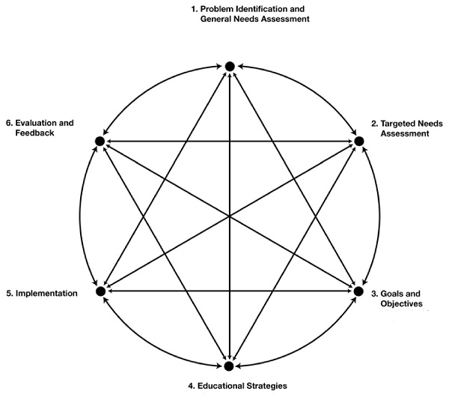
1. Students of 3rd year MBBS.
For the successful implementation of this curriculum we will need personal resources, teaching material, sufficient space, computer and internet facility. Regular curriculum committee meetings will held to discuss the implementation of curriculum. Also meetings will be done with all the stake holders.

2. TEACHING STRATIGIES:
Students are prepared for final exam on the pattern of UHS. Lectures, tutorials practical and viva are designed in a way to help students to get best preparation for their exam.
Regular program evaluations and feedbacks will be taken and changes will be incorporated into curriculum
OBJECTIVES:
.Students should get basic knowledge of Pharmacology during the 3rd year which forms their knowledge base for dental studies.

Our GOAL is to prepare our students with best available teaching methodologies so that they can pass with good grades.
- Lectures
- Tutorials
- Practical
- SGD ( small group discussions)
- Assignments
- Student presentations

Students are motivated to take part actively during all the educational sessions.

REFERENCE:
Kern DE, Thomas PA, Hughes MT editors. Curriculum development for medical education, A six-step approach. 2nd ed. United States of America: The Johns Hopkins University press; 2009.

- ORGANOGRAM OF PHARMACOLOGY DEPARTMENT

- Dr. Rubina Raza (MBBS)
- Dr. Humeria Mushtaq (MBBS)
- Dr. Amina Zubiar (MBBS)
- Dr. Bushra Haider (MBBS)
- Dr. Maria Liquat (MBBS)
- Dr. Rabail Ashraf (MBBS)

Dr. Ghulam Awais Qarni
MBBS
Senior Lecturer of Pharmacology Department
Dr. Asia Firdous
MBBS, M.Phil
Assistant Professor of Pharmacology Department
Dr. Wardah Siddique
MBBS, M.Phil
Assistant Professor of Pharmacology Department
Prof. Dr. Shazia Asim
MBBS, M.Phil
Professor of Pharmacology Department
Prof. Dr. Ajaz Fatima
MBBS, M.Phil
Professor of Pharmacology
Head of Pharmacology Department

