STUDY GUIDE FOR THIRD YEAR BDS

DEPARTMENT OF SURGERY

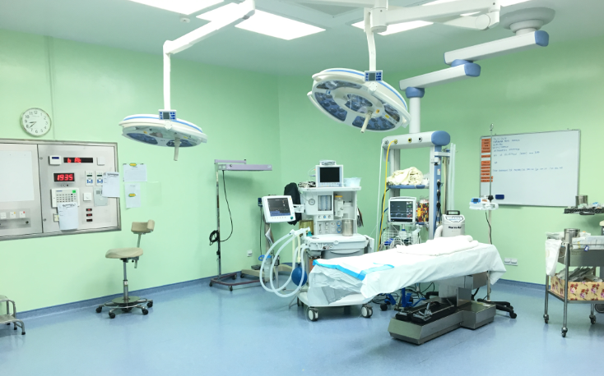

LAHORE MEDICAL AND DENTAL COLLEGE

CONTENTS
- Introduction
- Purpose of Guide
- Learning Audiences
- Learning Objectives
- Departmental staff hierarchy/ plan
- Content/Syllabus
- Teaching & Learning Methodologies
- Learning Resources
- Assessments Methods
- Google Class Room

INTRODUCTION
Medical education is a life-long process and BDS curriculum is a part of the continuum of education from pre-medical education, BDS, proceeding to house job, and post-graduation. PMC outlines the guiding principles for undergraduate medical curriculum and has defined the generic competencies and desired outcomes for a medical graduate to provide optimal health care, leading to better health outcomes for patients and societies. These generic competencies set the standards of care for all physicians and form a part of the identity of a doctor. Each competency describes a core ability of a competent physician. This study guide will give an insight to the students about all these competencies and how to plan their educational activities in the subject of surgery during third year BDS.

PURPOSE OF GUIDE: To facilitate learning of the student by enlightening about organization of the learning program, facilitate students in managing their studies through the academic year and guidance on assessments methods, exam rules and regulations.
TARGET AUDIENCE
3RD year BDS students

General Surgery
LEARNING OBJECTIVES (knowledge, skills, attitude)
- To equip the students with specific knowledge, essential skills and appropriate attitude towards the human body not just focusing on oral cavity
- To become problem solvers, dealing effectively with familiar and unfamiliar problems
- To become lifelong learners
- To direct their own learning and evaluate this activity
- To be able to reason critically and make justifiable decisions regarding patient management
- To practice evidence-based surgery
- To always ensure patient safety
- To ensure compliance with the legal system as it impacts health care and the PMC regulations
- To adopt a multidisciplinary approach for health promoting interventions
- Dental graduates should be able to demonstrate professional values of self and professional accountability, honesty, probity, and ethics
- Dental graduates are expected to demonstrate exemplary professional conduct
- To be able to understand the pathogenesis of specific surgical problems especially in head and neck region.
- To be able to take a thorough focused history and identify the patient’s risk factors related to the surgical diseases
- To be able to perform a physical examination on a patient, to diagnose specific surgical diseases and rule out other diseases
- To formulate a provisional diagnosis with justification, and the likely differential diagnoses
- To be able to select appropriate biochemical and microbiological investigations and interpret their reports to confirm the diagnosis
- To be able to select specific radiological investigations for specific diseases
- To be able to apply evidence-based general surgery concepts for the treatment of different diseases
- To be able to learn surgical skills

TEACHING METHODOLOGIES FOR SURGERY
- Interactive Lectures
- Tutorials
- Case based learning(CBL)
- Essential Skills to be learned in the skills lab
- Power point presentations by students
- Small group discussions
- Clinical ward rotations
- CPC’s – using modern audio-visual techniques, distant learning using electronic devices and current Information technology facilities
- Journal Club meetings
- Self-directed learning is the most vital part of this module to solve problematic cases, go through different learning resources and discuss with peers and the faculty to clarify difficult concepts

ATTENDANCE REQUIREMENT FOR GENERAL SURGERY
- Students are expected to attend all scheduled teaching sessions and examinations
- Attendance in lectures, tutorials, and wards is mandatory. Absence from these sessions will make the students ineligible to sit the final summative assessment.
- A minimum of 75 % attendance in the lectures and wards is mandatory to appear in the summative UHS examination
- Attendance will be recorded through a log-in/log-out biometrics system
- Absence due to illness must be certified appropriately by the General Physician

DURATION OF SESSION: April 2022 to January 2023

DEAPRTMENTAL STAFF HIERARCHY/ PLAN
Surgery Department Teaching Faculty for BDS class
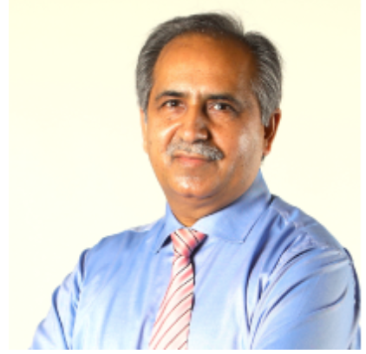
Prof Zahid Mahmood (Internal Examiner)
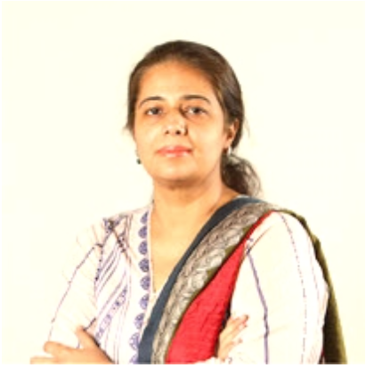
Dr. Maryum Jameel

COURSE TO BE STUDIED (syllabus)

Course outline for 3rd Professional BDS Session 2022

No | Days | Topics | Contents | MIT | Teacher
1 | wed | Infections  6 lectures | Wound healing and factors affecting wound healing  Complications of wound healing, Sinus, fistula,  Cellulitis, Abscess  Spread of infection through facial planes | lect. | Prof.Zahid Mahmood
2 | Thus | Infections  8 lectures | Cross infection control and sterilization  Hospital infections  Clinical presentation, diagnosis and treatment of bacterial, viral, fungal and protozoa infections  Intracranial complications of dental infections  Osteomyelitis | lect. | Dr. Maryam Jamil  (Assistant Professor)
3 | Wed | Salivary  Glands  5 lectures | Sialadenitis, Sialolithiasis, Sialosis, Sjogren’s syndrome  Mikulicz syndrome, Mucocele, Ranula  Benign and malignant tumors of salivary gland | lect. | Prof. Zahid Mahmood
4 | Wed | Oral Cavity  5 lectures | Epidemiology, classification, clinical presentation, diagnosis and treatment of benign and malignant tumors of oral cavity including epithelial, soft tissue and bone  Tongue, lips, buccal mucosa | lect. | Prof. Zahid Mahmood
5 | Wed | Neck  Pathology  10 lectures | Cervical lymphadenopathy, Branchial cyst, Dermoid cyst  Sternomastoid tumor, Cervical rib, Carotid body tumor  Carotid aneurysm, Thymic swelling, Cystic hygroma  Pharyngeal pouch, Spinal abscess  Thyroid gland. Thyroglossal cyst  Parathyroid gland | lect. | Prof. Zahid Mahmood
 |  |  | Mid Term Examination
6 | Thus | Trauma  4 lectures | Principles of pre-hospital, emergency and definitive care of trauma victim with special emphasis on management of  Airway, Breathing, Circulation, CPR protocols  Head injury, Chest trauma, Abdominal trauma  Maxillofacial trauma  Principle of fracture healing | lect. | Dr. Maryam Jamil  (Assistant Professor)
7 | Thus | Neoplasia  4 lectures | Definition  Difference between benign and malignant tumors  Carcinogens, Characteristics of malignancy  Method of spread, Diagnosis  Treatment, Radiotherapy complications  Chemotherapy complications  Basal cell CA, Squamous cell CA  Melanoma, Osteosarcoma | lect. | Dr. Maryam Jamil  (Assistant Professor)
8 | Thus | Hemorrhage, shock, burns  8 lectures | Causes, presentation, diagnosis and management of primary and secondary and reactionary hemorrhage, nutrition, fluid therapy  Vasovagal, cardiogenic, septic, anaphylactic, neurogenic hypoglycemic and hypovolemic shock | lect. | Dr. Maryam Jamil  (Assistant Professor)
9 | Thus | Larynx, Maxilla, Trachea& Esophagus (8. lecturers) | Maxillary sinusitis  Carcinoma Maxillary sinus, Carcinoma Larynx, Tracheostomy, Ca esophagus  Achalasia Cleft lip, Cleft palate | lect. | Dr. Maryam Jamil  (Assistant Professor)
 |  |  | Send up |  | December 2022

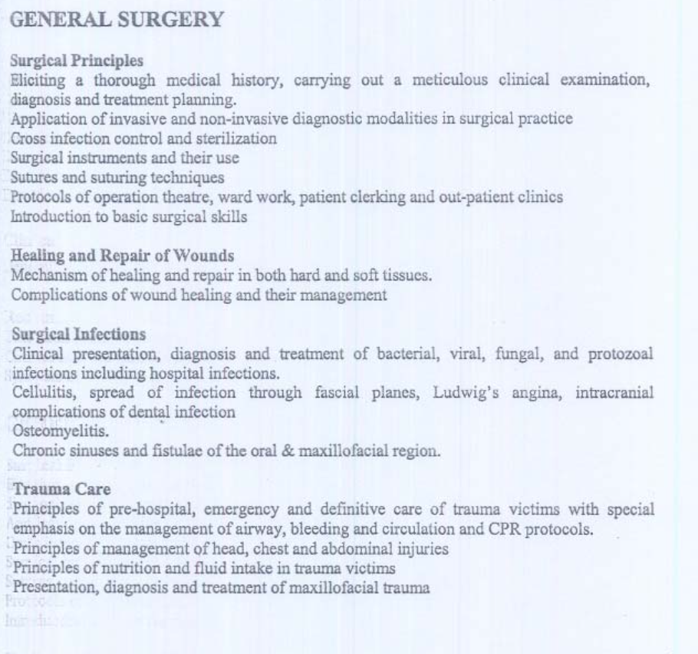
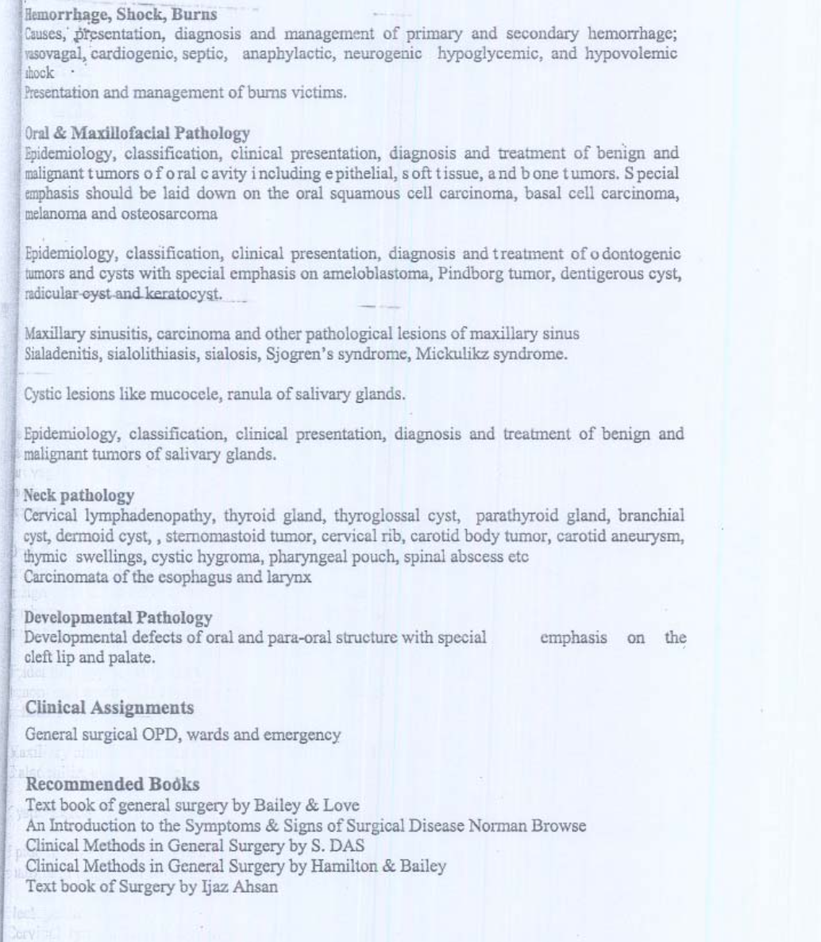

ASSESSMENT METHODOLOGY
Formative
Theory, single best multiple choice question and SEQ test at the end of each topic finished and all topics tests at end of session
Clinical ward test, comprising of 2 short cases (70 marks) and OSPE comprising of 10 stations (30 marks)
Total marks= 100

MARKS UHS PAPER
SEQ 45
MCQ 45
Clinical 90 (30 OSPE, 30 each for internal and external examiner)
Internal Assessment 20
Total 200

LEARNING RESOURCES
Recommended books
- Textbook of surgery by baileys and love
- An introduction of symptoms & Signs of diseases by Norman Browse
- Clinical methods in general surgery by S. Das
- Text book of surgery by Ejaz Ahsan

Technologies to be used
- Textbooks are the most important part of student learning for this subject
- Bed side learning with patients
- Hands-on activities and practical sessions to enhance the learning.
- Skills lab will be used for simulated learning of the basic skills related to the gastrointestinal system
- Videos from different web portals to familiarize the students with the procedures and protocols.
- Computer and Internet resources are essential to gather the latest information about a specific disease.
- Google Classroom Link (https://classroom.google.com/c/NDc5NTg3NTU4OTgx

