Study Guide (2022)
Department of Orthodontics
College of Dentistry, Lahore Medical & Dental College

Course Director:

Prof. Asma Shafique BDS, FCPS, FICD ,MSc. HSEd Head of the Department

Contributors:

Dr, Usman Zaheer BDS, FCPS, M Orth. RCSEd Assistant professor
Dr.Usman Ghani BDS, FCPS Senior Registrar
Dr. Asad Ur Rehman BDS, FCPS Senior Registrar

Co Contributors:
Dr. Maira BDS, FCPS residency completed Demonstrator
Dr. Fahad BDS, FCPS residency completed Demonstrator
Dr. Hibbah Khalid BDS Demonstrator
Dr. Saleha Fatima BDS Demonstrator
DEPARTMENT OF ORTHODONTICS & DENTOFACIAL ORTHOPAEDICS
INTRODUCTION:
Scope of Department: Orthodontics is a field of dentistry, concerned with the growth of teeth, jaws and face. Orthodontics is about making the best of one’s teeth and ensuring they are in harmony with mouth and jaw.
Services Offered: The Orthodontic Department, at LMDC, undertakes a range of procedures. These include straightening crowded, misplaced and impacted teeth to improve appearance and ultimately to make it easier to eat and care for your teeth. Full range of Preventive, Interceptive & Corrective measures is available. The orthodontics procedures are often very complex specialist work that is combined with those of maxillofacial surgeons who are treating patients with severe facial deformity. In addition, orthodontics also works alongside the Restorative Dentistry Department for patients undergoing treatment for multiple missing teeth who require crowns, bridges and implants.
OBJECTIVES OF DEPARTMENT
The main role of our department is to educate students to become proficient at treating the broad scope of occlusal and dentofacial malocclusions. Special emphasis is placed on diagnosis and treatment planning, growth and development, biomechanics, and occlusion, using research to help develop critical thinking and writing skills while making a significant contribution to the scientific literature. Objectives can be summed up as to:
- Impart quality education to undergraduate students (future clinicians) with special emphasis on required practical knowledge.
- Supervise clinical training for House officers and Postgraduates during house job and residency program respectively.
- Provide specialist care for general public at nominal charges.
GENERAL INFORMATION FOR UNDERGRADUATE STUDENTS:
In the undergraduate program, we facilitate the students in didactic and clinical teaching of orthodontics. The department is also recognized as the center of FCPS training by the College of Physicians and Surgeons of Pakistan. Our mission at LMDC is to provide the best learning experience to the budding dentists and specialists. The department of Orthodontics is actively involved in Continuous Dental Education activities. We diligently work towards this undertaking by conducting weekly seminars and journal clubs.
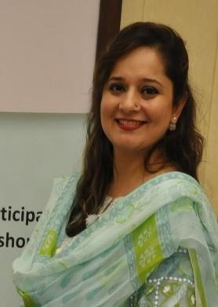
FACULTY

1. PROF. ASMA SHAFIQUE
DESIGNATION: HEAD / PROFESSOR OF ORTHODONTICS
QUALIFICATIONS: MSc HSED, FICD, FCPS (ORTHODONTICS), BDS
ADDRESS: 314/A THE UPPER MALL LAHORE.
CONTACT NUMBER: 92 3464418891/175

2. DR. USMAN ZAHEER
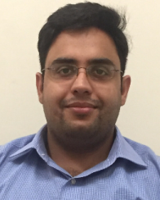
DESIGNATION: ASSISTANT PROFESSOR ORTHODONTICS
QUALIFICATIONS: FCPS (ORTHODONTICS), BDS, M Orth RCSEd. CHPE
ADDRESS: B-440 ASKARI 10 NEW AIRPORT LAHORE CANTT
CONTACT NUMBER: 92 3464418891/173

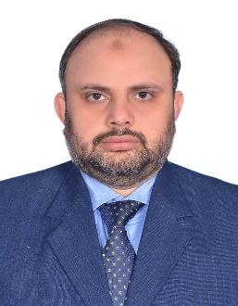
3.DR. M. USMAN GHANI
DESIGNATION: SENIOR REGISTRAR ORTHODONTICS
QUALIFICATIONS: FCPS (ORTHODONTICS), BDS, CHPE
ADDRESS: 66 AHMED YAR BLOCK, MUSTAFA TOWN LAHORE
CONTACT NUMBER: 92 3464418891/149

4.DR. ASAD UR REHMAN
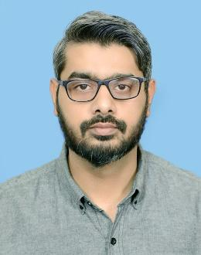
DESIGNATION: SENIOR REGISTRAR ORTHODONTICS
QUALIFICATIONS: FCPS (ORTHODONTICS), BDS
ADDRESS: HOUSE NO 26. GULISTAN-E-RAH TAJ BAGH LAHORE
CONTACT NUMBER: 92 3464418891/149

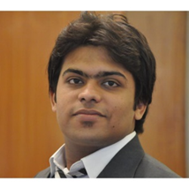
5. DR. FAHAD CHAUDHRY
DESIGNATION: DEMONSTRATOR/RESIDENT (FCPS II)
QUALIFICATIONS: FCPS (Part 1), BDS
ADDRESS: SD-98 FALCON COMPLEX GULBERG III, LAHORE
CONTACT NUMBER: 92 3464418891/149

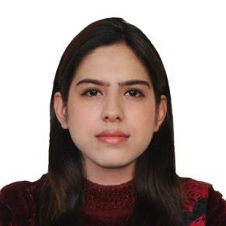
6. DR. MAIRA MUBASHIR
DESIGNATION: DEMONSTRATOR/RESIDENT (FCPS II)
QUALIFICATIONS: FCPS (Part I), BDS
ADDRESS: PHASE IV DHA, LAHORE.
CONTACT NUMBER: 92 3464418891/149

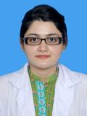
7. DR. HIBA KHALID
DESIGNATION: DEMONSTRATOR
QUALIFICATIONS: BDS
ADDRESS: 222-1 L BLOCK PHASE I DHA, LAHORE.
CONTACT NUMBER: 92 3464418891/149

8. DR. SALEHA FATIMA
DESIGNATION: DEMONSTRATOR
QUALIFICATIONS: BDS
CONTACT NUMBER: 92 3464418891/149

UNDERGRADUATE TEACHING PROGRAMME:
The undergraduate curriculum comprises of didactic, psychomotor and affective components.
The didactic component is designed to achieve a thorough understanding of
- Diagnosis
- Etiology
- Treatment planning
- Treatment of malocclusion
The psychomotor component consists of exercises for developing the psychomotor skills which include:
- Wire bending techniques.
- Fabrication of removable orthodontic appliances.
- Tracing, evaluation and interpretation of cephalogram.
- Clinical examination of orthodontic patients.
The affective component consists of exercises to
- Handle orthodontic patients (and accompanying parents) at chair side.
- Council patients requiring preventive and interceptive orthodontics.
- Empathize with patients have dentofacial asymmetry or syndromes.
Curriculum Map
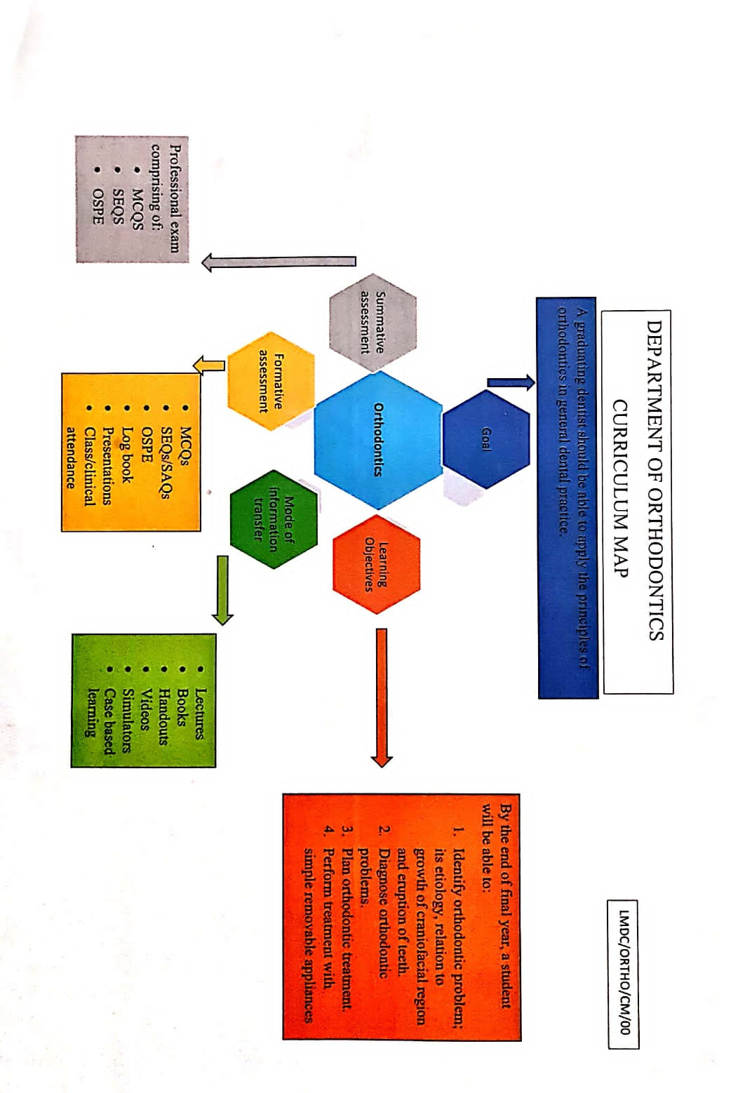

CURRICULUM OF ORTHODONTICS

THE DIDACTIC COMPONENT
General Learning Objectives: by the end of the course the student will be able to:
- Identify normal and abnormal facial growth, physical, mental and dental development and explain their significance
- Recognize the development of dentition and occlusion.
- Distinguish features of occlusal anomalies and recognize normal occlusion from malocclusion aiding clinical diagnosis.
- Identify diagnosis, interception and treatment of the malocclusion
- Understand the problem-oriented approach to diagnosis and treatment planning
- Undertake an orthodontic assessment, including an indication of treatment need
- Learn how to evaluate the major sources: (1) patient questioning, (2) clinical examination of the patient and (3) Diagnostic records, including dental casts, radiographs, and photographs.
- Identify and explain developmental or acquired occlusal Abnormalities
- Identify and explain the principles of interceptive treatment, including timely interception and interceptive orthodontics, and refer when and where appropriate
- Identify and explain when and how to refer patients for specialist treatment and apply to practice
- Acquire basic understanding of fixed appliance mechanics.
- Develop an understanding of combined surgical and orthodontic therapy and should be able to explain the procedures and their sequencing with orthodontic treatment. That should include timing, preoperative orthodontics, surgical procedures, and postoperative orthodontics and anticipated results.
- Recognize and explain to patients the range of contemporary orthodontic treatment options, their impact, outcomes, limitations and risks
- Undertake limited orthodontic appliance emergency procedures
Relate Orthodontics to other dental sciences
CURRICULUM

Malocclusion and Dentofacial Deformity in Contemporary Society

Course Director: Prof. Asma Shafique

Total Time Allocation for Theory
Total Number of Lectures
1 Lecture = 60 minutes.
Chapter: 1 (6th edition Contemporary Orthodontics)
Page no: 1-13
Weightage of Assessment in the Syllabus

Topic | SEQS | MCQS | OSCEs
Malocclusion and Dento facial Deformity in Contemporary society | 1 | 1 | 1

Concepts of Growth and Development

Course Director: Prof. Asma Shafique

Total Time Allocation for Theory:
Total Number of Lectures:
1 lecture = 60 minutes.
Chapter: 2 (6th edition Contemporary Orthodontics)
Page no: 18-46

Weightage of Assessment in the Syllabus:
Topic | SEQS | MCQS | OSCEs
Concepts of Growth and Development | 1 | 4 | 1

Early Stages of Development

Course Director: Prof. Asma Shafique

Total Time Allocation for Theory
Total Number of Lectures
1 lecture = 60 minutes.
Chapter: 3 (6th edition Contemporary Orthodontics)
Page no: 60-83

Weightage of Assessment in the Syllabus
Topic | SEQS | MCQS | OSCEs
Early stages of development | 1 | 2 | 1

Later Stages of Development

Course Director: Prof. Asma Shafique

Total Time Allocation for Theory
Total Number of Lectures
1 Lecture = 60 minutes.
Chapter: 4 (6th edition Contemporary Orthodontics)
Page no: 84-106
Weightage of Assessment in the Syllabus
Topic | SEQS | MCQS | OSCEs
Later stages of development | 1 | 3 | 1

Etiology of Orthodontic Problems
Course Director: Prof. Asma Shafique

Total Time Allocation for Theory
Total Number of Lectures
1 Lecture = 60 minutes
Chapter: 5 (6th edition Contemporary Orthodontics)
Page no: 107-139

Weightage of Assessment in the Syllabus
Topic | SEQS | MCQS | OSCEs
Etiology of Orthodontic Problems |  | 2 | 1

Andrew’s Six Keys of Ideal Occlusion

Course Director: Dr. Usman Zaheer

Total Time Allocation for Theory 2 HOURS
Total Number of Lectures 2
1 lecture = 60 minutes.
Chapter: 2 (2nd Handbook of Orthodontics)
Page no: 10-12
Weightage of Assessment in the syllabus 2.22%
Topic | SEQS | MCQS | OSCEs
Andrew’s Six Keys of Ideal Occlusion | 1 | 1 | 1

Orthodontic Diagnosis: The Problem Oriented Approach

Course Director: Dr. Asad Ur Rehman / Dr. Usman Ghani

Total Time Allocation for Theory
Total Number of Lectures
1 Lecture = 60 minutes.
Chapter: 6 (6th edition Contemporary Orthodontics)
Page no: 140-207

Weightage of Assessment in the Syllabus
Topic | SEQS | MCQS | OSCEs
Orthodontic Diagnosis: The Problem Oriented Approach | 1 | 5 | 1

Orthodontic Treatment Planning: From Problem List to Specific Plan

Course Director: Dr. Asad Ur Rehman / Dr. Usman Ghani

Total Time Allocation for Theory
Total Number of Lectures
1 Lecture = 60 minutes.
Chapter: 7 (6th edition Contemporary Orthodontics)
Page no: 208-247

Weightage of Assessment in the Syllabus
Topic | SEQS | MCQS | OSCEs
Orthodontic Treatment Planning: From Problem List to Specific Plan | 1 | 2 | 1

Biologic Basis of Orthodontic Treatment
Course Director: Dr. Usman Zaheer

Total Time Allocation for Theory hours
Total Number of Lectures
1 Lecture = 60 minutes.
Chapter: 8 (6th edition Contemporary Orthodontics)
Page no: 248-275

Weightage of Assessment in the Syllabus 2.22%

Topic | SEQS | MCQS | OSCEs
Biologic Basis of Orthodontic Treatment | 1 | 1 | 1
Mechanical Principles in Orthodontic Force Control

Course Director: Dr. Usman Zaheer

Total Time Allocation for Theory
Total Number of Lectures
1 Lecture = 60 minutes.
Chapter: 9 (6th edition Contemporary Orthodontics)
Page no: 276-299

Weightage of Assessment in the Syllabus
Topic | SEQS | MCQS | OSCEs
Mechanical Principles in Orthodontic Force Control | 2 | 2 | 1

Contemporary Orthodontic Appliance

Course Director: Dr. Usman Zaheer

Total Time Allocation for Theory
Total Number of Lectures
1 Lecture = 60 minutes.
Chapter: 10 (6th edition Contemporary Orthodontics)
Page no: 310-355

Weightage of Assessment in the Syllabus

Topic | SEQS | MCQS | OSCEs
Contemporary Orthodontic Appliance | 1 | 3 | 1

Moderate Non-skeletal Problems in Preadolescent Children: Preventive and Interceptive Treatment in Family Practice
Course Director: Prof. Asma Shafique / Dr. Usman Ghani

Total Time Allocation for Theory
Total Number of Lectures
1 Lecture = 60 minutes
Chapter: 11 (6th edition Contemporary Orthodontics)
Page no: 356-401

Weightage of Assessment in the Syllabus
Topic | SEQS | MCQS | OSCEs
Moderate Non-skeletal Problems in Preadolescent Children: Preventive and Interceptive Treatment in Family Practice | 2 | 7 | 1

Complex Non skeletal Problems in Preadolescent Children: Preventive and Interceptive Treatment

Course Director: Prof. Asma Shafique/ Dr. Usman Ghani

Total Time Allocation for Theory
Total Number of Lectures
1 Lecture = 60 minutes
Chapter: 12 (6th edition Contemporary Orthodontics)
Page no: 402-429
Weightage of Assessment in the Syllabus
Topic | SEQS | MCQS | OSCEs
Complex Non skeletal Problems in Preadolescent Children: Preventive and Interceptive Treatment | 1 | 5 | 1

First Stage of Comprehensive Treatment; Alignment and Leveling

Course Director: Dr. Usman Zaheer

Total Time Allocation for Theory
Total Number of Lectures
1 Lecture = 60 minutes.
Chapter: 15 (6th edition Contemporary Orthodontics)
Page no: 501-527

Weightage of Assessment in the Syllabus
TOPIC | SEQS | MCQS | OSCEs
First Stage of Comprehensive Treatment; Alignment and Leveling |  | 1 | 1

The Second Stage of Comprehensive Treatment: Correction of Molar Relationship and Space Closure

Course Director: Dr. Asma Shafique/Dr. Usman Zaheer

Total Time Allocation for Theory
Total Number of Lectures
1 Lecture = 60 minutes.
Chapter: 16 (6th edition Contemporary Orthodontics)
Page no: 528-555
Weightage of Assessment in the Syllabus
Topic | SEQS | MCQS | OSCEs
The Second Stage Of Comprehensive Treatment: Correction of Molar Relationship and Space Closure |  | 1 | 1

Third Stage of Comprehensive Treatment; Treatment Finishing

Course Director: Dr. Usman Zaheer

Total Time Allocation for Theory
Total Number of Lectures
1 Lecture = 60 minutes.
Chapter: 17 (6th edition Contemporary Orthodontics)
Page no: 556-579

Weightage of Assessment in the Syllabus
Topic | SEQS | MCQS | OSCEs
Third Stage of Comprehensive Treatment; Treatment Finishing |  | 1 | 1

Retention
Course Director: Dr. Usman Zaheer

Total Time Allocation for Theory
Total Number of Lectures
1 Lecture = 60 minutes.
Chapter: 18 (6th edition Contemporary Orthodontics)
Page no: 579-599

Weightage of Assessment in the Syllabus
Topic | SEQS | MCQS | OSCEs
Retention |  | 1 | 1

Special Considerations in Treatment for Adults
Course Director: Dr. Asad Ur Rehman/ Dr. Usman Ghani

Total Time Allocation for Theory
Total Number of Lectures
1 Lecture = 60 minutes
Chapter: 19 (6th edition Contemporary Orthodontics)
Page no: 600-655

Weightage of Assessment in the Syllabus
Topic | SEQS | MCQS | OSCEs
Special Considerations in Treatment for Adults | 1 | 1 | 1

Combined Surgical and Orthodontic Treatment
Course Director: Prof. Asma Shafique

Total Time Allocation for Theory
Total Number of Lectures
1 Lecture = 60 minutes
Chapter: 20 (6th edition Contemporary Orthodontics)
Page no: 657-692

Weightage of Assessment in the Syllabus
Topic | SEQS | MCQS | OSCEs
Combined Surgical and Orthodontic Treatment | 1 | 2 | 1

TABLE OF SPECIFICATIONS FOR ORTHODONTICS

Total Topics: 22
Total Lectures: 90

No. | Learning Outcomes | Weightage in % | Time in Hours
1. | Growth and development | 14.44% | 13
2. | Classification of malocclusion | 6.66% | 6
3. | Diagnosis in orthodontics | 6.66% | 6
4. | Andrews six keys of occlusion | 2.22% | 2
5. | Etiology of malocclusion | 2.22% | 2
6. | Development of occlusion & mix dentition | 4.44% | 4
7. | Space management protocols | 3.33% | 3
8. | biomechanics | 12.22 % | 11
9. | Fixed appliances | 2.22 % | 2
10. | Removable appliances | 2.22 % | 2
11. | Treatment planning in class I malocclusion | 12.22% | 11
12. | Treatment planning in class II malocclusion | 2.22% | 2
13. | Treatment planning in class III malocclusion | 3.33% | 3
14. | Bonding in orthodontics | 1.11 % | 1
15. | Banding in orthodontics | 1.11 % | 1
16. | Extractions in orthodontics | 2.22 % | 2
17. | Adjunctive orthodontics | 2.22% | 2
18. | Comprehensive orthodontics | 2.22% | 2
19. | Functional appliances | 7.77% | 7
20. | Surgical Orthodontics | 2.22% | 2
21. | Cleft lip and palate | 2.22 % | 2
22. | Syndromes | 2.22 % | 2
23. | Radiology | 2.22 % | 2

ACADEMIC CALENDER OF DEPARTMENT OF ORTHODONTICS FOR THE YEAR 2021-2022

Final year lecture on Tuesday at 07:30 -08:30 AM
Final year lectures on Friday at 07:30 -9:30 AM
Departmental seminar on Monday at 8:30 am
Topics | Lecture delivered by |  | Day | Venue | Time
Introduction to orthodontics | Dr. Asma Shafique |  | Tuesday | Lecture theatre 6 | 8:00-9:00am
Andrew’s six key of occlusion | Dr. Usman Zaheer |  | Tuesday | Lecture theatre 6 | 8:00-9:00am
Importance of the topic, Definitions, terminologies, theories of growth control | Dr. Asma Shafique |  | Friday | Lecture theatre 6 | 8:00-10:00am
Importance of classification | Dr. Usman Zaheer |  | Tuesday | Lecture theatre 6 | 8:00-9:00am
Theories of growth control | Dr. Asma Shafique |  | Friday | Lecture theatre 6 | 8:00-10:00am
Classification systems of malocclusion | Dr. Usman Zaheer |  | Tuesday | Lecture theatre 6 | 8:00-9:00am
Theories of growth control | Dr. Asma Shafique |  | Friday | Lecture theatre 6 | 8:00-10:00am
Classification of malocclusion | Dr. Usman Zaheer |  | Tuesday | Lecture theatre 6 | 8:00-9:00am
Fixed appliances | Dr. Usman  Zaheer |  | Tuesday | Lecture theatre 6 | 8:00-9:00am
Growth of cranial vault and basicranium | Dr. Asma Shafique |  | Friday | Lecture theatre 6 | 8:00-10:00am
Classification of malocclusion | Dr. Usman Zaheer |  | Tuesday | Lecture theatre 6 | 8:00-9:00am
Fixed appliances | Dr. Usman Zaheer |  | Tuesday | Lecture theatre 6 | 8:00-9:00am
Growth of mandible | Dr. Asma Shafique |  | Friday | Lecture theatre 6 | 8:00-10:00am
Classification of malocclusion | Dr. Usman Zaheer |  | Tuesday | Lecture theatre 6 | 8:00-9:00am
Bonding and banding in orthodontics | Dr. Usman Ghani |  | Tuesday | Lecture theatre 6 | 8:00-9:00am
Growth terminologies | Dr. Asma Shafique |  | Friday | Lecture theatre 6 | 8:00-10:00am
Importance of diagnosis | Dr. Asad Ur Rehman |  | Tuesday | Lecture theatre 6 | 8:00-9:00am
Biomechanics | Dr. Usman Zaheer |  | Tuesday | Lecture theatre 6 | 8:00-9:00am
Growth of nasomaxillary complex | Dr. Asma Shafique |  | Friday | Lecture theatre 6 | 8:00-10:00am
History taking in orthodontics | Dr. Asad Ur Rehman |  | Tuesday | Lecture theatre 6 | 8:00-9:00am
Physiological response to tooth movement | Dr. Usman Zaheer |  | Tuesday | Lecture theatre 6 | 8:00-9:00am
Growth and development of mandible and TMJ | Dr. Asma Shafique |  | Friday | Lecture theatre 6 | 8:00-10:00am
Intra and extra oral examination and its importance | Dr. Asad Ur Rehman |  | Tuesday | Lecture theatre 6 | 8:00-9:00am
Normal structure of periodontal ligament and bone, biological control of tooth movement | Dr. Usman Zaheer |  | Tuesday | Lecture theatre 6 | 8:00-9:00am
Rotations of jaws during growth | Dr. Asma Shafique |  | Friday | Lecture theatre 6 | 8:00-10:00am
Intra oral examination | Dr. Asad Ur Rehman |  | Tuesday | Lecture theatre 6 | 8:00-9:00am
Physiological response of PDL & alveolar bone to sustained orthodontic forces | Dr. Usman Zaheer | Tuesday |  | Lecture theatre 6 | 8:00-9:00am
Growth and development | Dr. Asma Shafique | Friday |  | Lecture theatre 6 | 8:00-10:00am
Cast analysis | Dr. Asad Ur Rehman | Tuesday |  | Lecture theatre 6 | 8:00-9:00am
Types of  orthodontic forces | Dr. Usman Zaheer | Tuesday |  | Lecture theatre 6 | 8:00-9:00am
Growth and  Development | Dr. Asma Shafique | Friday |  | Lecture theatre 6 | 8:00-10:00am
Introduction to treatment planning | Dr. Asad Ur Rehman | Tuesday |  | Lecture theatre 6 | 8:00-9:00am
Drug effects on orthodontics | Dr. Usman Zaheer | Tuesday |  | Lecture theatre 6 | 8:00-9:00am
Importance of etiology of malocclusion | Dr. Asma Shafique | Friday |  | Lecture theatre 6 | 8:00-10:00am
Introduction to treatment planning | Dr. Asad Ur Rehman | Tuesday |  | Lecture theatre 6 | 8:00-9:00am
Deleterious effects of orthodontics | Dr. Usman Zaheer | Tuesday |  | Lecture theatre 6 | 8:00-9:00am
Etiology of malocclusion | Dr. Asma Shafique | Friday |  | Lecture theatre 6 | 8:00-10:00am
Crowding | Dr. Asad Ur Rehman | Tuesday |  | Lecture theatre 6 | 8:00-9:00am
Anchorage in orthodontics | Dr. Usman Zaheer | Tuesday |  | Lecture theatre 6 | 8:00-9:00am
Mixed dentition | Dr. Asma Shafique | Friday |  | Lecture theatre 6 | 8:00-10:00am
Spacing | Dr. Asad Ur Rehman | Tuesday |  | Lecture theatre 6 | 8:00-9:00am
Metallurgy | Dr. Usman Zaheer | Tuesday |  | Lecture theatre 6 | 8:00-9:00am
Mixed dentition | Dr. Asma Shafique | Friday |  | Lecture theatre 6 | 8:00-10:00am
Anterior cross bite | Dr. Usman Ghani | Tuesday |  | Lecture theatre 6 | 8:00-9:00am
Metallurgy | Dr. Usman Zaheer | Tuesday |  | Lecture theatre 6 | 8:00-9:00am
Space maintenance | Dr. Asma Shafique | Friday |  | Lecture theatre 6 | 8:00-10:00am
Posterior cross bite | Dr. Usman Ghani | Tuesday |  | Lecture theatre 6 | 8:00-9:00am
Retention in orthodontics | Dr. Usman Zaheer | Tuesday |  | Lecture theatre 6 | 8:00-9:00am
Space maintenance | Dr. Asma Shafique | Friday |  | Lecture theatre 6 | 8:00-10:00am
Expansion | Dr. Usman Ghani | Tuesday |  | Lecture theatre 6 | 8:00-9:00am
Relapse in orthodontics | Dr. Usman Zaheer | Tuesday |  | Lecture theatre 6 | 8:00-9:00am
Extraction in orthodontics | Dr. Asad Ur Rehman | Friday |  | Lecture theatre 6 | 8:00-10:00am
Deep bite | Dr. Usman Ghani | Tuesday |  | Lecture theatre 6 | 8:00-9:00am
Functional appliances | Dr. Asma Shafique | Friday |  | Lecture theatre 6 | 8:00-10:00am
Extraction in orthodontics | Dr. Asma Shafique | Friday |  | Lecture theatre 6 | 8:00-10:00am
Open bite | Dr. Usman Ghani | Tuesday |  | Lecture theatre 6 | 8:00-9:00am
Functional appliances | Dr. Asma Shafique | Friday |  | Lecture theatre 6 | 8:00-10:00am
Syndromes in orthodontics | Dr. Asma Shafique | Friday |  | Lecture theatre 6 | 8:00-10:00am
Supernumerary teeth | Dr. Usman Zaheer | Tuesday |  | Lecture theatre 6 | 8:00-9:00am
Functional appliances | Dr. Asma Shafique | Friday |  | Lecture theatre 6 | 8:00-10:00am
Syndromes in orthodontics | Dr. Asma Shafique | Friday |  | Lecture theatre 6 | 8:00-10:00am
Canine impaction | Dr. Usman Zaheer | Tuesday |  | Lecture theatre 6 | 8:00-9:00am
Functional appliances | Dr. Asma Shafique | Friday |  | Lecture theatre 6 | 8:00-10:00am
Adjunctive orthodontics | Dr. Asad Ur Rehman | Friday |  | Lecture theatre 6 | 8:00-10:00am
Treatment planning | Dr. Asad Ur Rehman | Tuesday |  | Lecture theatre 6 | 8:00-9:00am
Functional appliances | Dr. Asma Shafique | Friday |  | Lecture theatre 6 | 8:00-10:00am
Adjunctive orthodontics | Dr. Asad Ur Rehman | Friday |  | Lecture theatre 6 | 8:00-10:00am
Treatment of class II malocclusion | Dr. Asma Shafique | Friday |  | Lecture theatre 6 | 8:00-10:00am
Functional appliances | Dr. Asma Shafique | Friday |  | Lecture theatre 6 | 8:00-10:00am
Comprehensive orthodontics | Dr. Usman Ghani | Friday |  | Lecture theatre 6 | 8:00-10:00am
Treatment of class II malocclusion | Dr. Asma Shafique | Friday |  | Lecture theatre 6 | 8:00-10:00am
Radiology | Dr. Usman Zaheer | Tuesday |  | Lecture theatre 6 | 8:00-9:00am
Comprehensive orthodontics | Dr. Usman Ghani | Friday |  | Lecture theatre 6 | 8:00-10:00am
Head gears | Dr. Asma Shafique | Friday |  | Lecture theatre 6 | 8:00-10:00am
Class III malocclusion | Dr. Usman Zaheer | Friday |  | Lecture theatre 6 | 8:00-10:00am
Head gears II | Dr. Asma Shafique | Friday |  | Lecture theatre 6 | 8:00-10:00am
Class III malocclusion | Dr. Usman Zaheer | Friday |  | Lecture theatre 6 | 8:00-10:00am
Class III malocclusion | Dr. Usman Zaheer | Friday |  | Lecture theatre 6 | 8:00-10:00am
Surgical orthodontics | Dr. Asma Shafique | Friday |  | Lecture theatre 6 | 8:00-10:00am
Surgical orthodontics | Dr. Asma Shafique | Friday |  | Lecture theatre 6 | 8:00-10:00am
Cleft lip and palate | Dr. Asma Shafique | Friday |  | Lecture theatre 6 | 8:00-10:00am
Cleft lip and palate | Dr. Asma Shafique | Friday |  | Lecture theatre 6 | 8:00-10:00am

REFERENCES & SUPPORTING MATERIAL
It is highly recommended that students read from sources other than lecture notes.
- Strongly recommended Books :
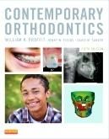
- Mosby Title
ISBN: 978-0-323-08317-1
Contemporary Orthodontics, 6th Edition
By William R. Proffit, DDS, PhD, Henry W. Fields, Jr., DDS, MS, MSD and David M. Sarver, DMD, MS 768 pages
Now in full color, Contemporary Orthodontics, 6th Edition is a practical resource with a long tradition of excellence. Line drawings and more than 1,000 new color images illustrate concepts more clearly than ever. This book includes detailed information on diagnosis, treatment planning concepts, related problems or controversies, and current treatment procedures, including the role of orthodontics in comprehensive treatment of patients with multiple problems.
Contemporary Orthodontics, 6th edition, is a practical resource with a long tradition of excellence. This edition has been extensively revised to maintain the original goal of the book: to provide an up-to-date overview of orthodontics that is accessible to both undergraduate and postgraduate students and a valuable reference for practitioners...The key elements fundamental in acquiring contemporary orthodontic skills are summarized in a coherent fashion. This text deserves to become the vade mecum for the aspiring orthodontist or clinician.

Supplementary Books :

An Introduction to Orthodontics Fourth Edition, Laura Mitchell. January 2013 ISBN: 9780199594719 336
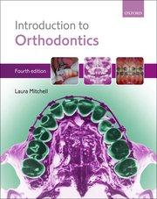
Introduction to Orthodontics, Fourth Edition, is an ultimate resource for students new to the study of orthodontics and a helpful reference text for practicing dental clinicians.
- A new edition of a classic text, covering all areas of the field, explaining theory and demonstrating practical techniques
- Comprehensive case studies that take the reader from the beginning to the end of complex orthodontic treatment
- Student-friendly design that includes learning objectives, key points, and annotated further reading
- Extensively illustrated with over 700 colour photographs and line drawings to aid revision
New to this edition
- Three new case studies supported by extensive photographic records and treatment plans
- Where applicable, chapters now include directions to key Cochrane reviews relating to the subject matter
- All chapters now begin with learning objectives - an ideal revision tool
- Includes fully updated and annotated further reading for each chapter

Handbook of Orthodontics

2nd Edition Authors: Martyn Cobourne Andrew DiBiase
eBook ISBN: 9780723439530 eBook ISBN: 9780723439592
Paperback ISBN: 9780723438076 Imprint: Elsevier Published Date: 2nd October 2015 Page Count: 584

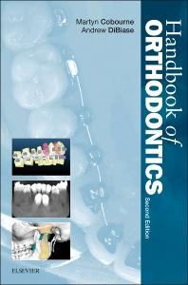

Description
The second edition of the popular Handbook of Orthodontics continues to offer readers a highly accessible introduction to the subject of clinical orthodontics. Comprehensive and compact, this book is ideal for dental undergraduates, postgraduate students of orthodontics and orthodontic therapists, as well as general dental practitioners with an interest in the field.

Key Features
- Portable format makes the book ideal for use as an ‘on-the-spot’ quick reference
- Provides comprehensive coverage of clinical orthodontics ranging from diagnosis and treatment planning through contemporary removable and fixed appliances to cleft lip and palate
- Covers the scientific basis of orthodontics in detail with particular focus on embryology, craniofacial development, growth and the biology of tooth movement

THE PSYCHOMOTOR COMPONENT/PRACTICAL AND CLINICAL ORTHODONTICS
GENERAL LEARNING OBJECTIVES: By the end of final year students will be able to:
- Obtain demographic information, medical, dental history, history of paranormal habits, growth and development.
- Perform intraoral and extraoral clinical Examination of orthodontic patients.
- Analyze the orthodontic problem and classify malocclusion.
- Plan simple orthodontic treatment by employing removable appliances.
- Enable them to fabricate removable and certain fixed appliances for preventive, interceptive and minor corrective procedures in orthodontics.
- Design and fabricate selective removable appliances.
- Insert, activate and remove simple removable appliances
- Perform general cast analysis, space analysis and mixed dentition analysis.
- Trace and perform lateral Cephalometric analysis an diagnose orthodontic problem based on the findings.
- Interpret other radiographs including OPG and hand & wrist radiographs.
THE PRACTICAL WORK:
The practical work comprises of:
- Wire bending exercises including

- Adams clasps
- Labial bow
- Palatal finger springs
- Z springs

- Fabrication of removal appliances
- Complete history taking
- Intra and extra oral examination
- Bolton analysis
- Mixed dentition analysis
- Adult/permanent space analysis
- Cephalometric analysis
- Cervical vertebrae maturation stages and Hand & Wrist radiographic analysis for skeletal growth status

MATERIAL REQUIRED
- Log book
- Instruments
- Geometry box.
INSTRUMENTS
Following common instruments are required for fabrication of majority of removable appliances:
ADAM’S PLIER
These are used for making of Adam’s clasp. The beaks are stout, tapered and rectangular in section and meet only at the tips. Beaks that are in contact throughout their length tend to eject a larger diameter wire. The beaks of Adam’s pliers are parallel when gripping the wire.
BIRDBEAK PLIER
These have round tapered beaks around which loops or coils of various sizes may be formed.
WIRE CUTTER
The diagonal type of wire cutter is used and must have hardened blades.

DETAILS OF CLINICAL COMPONENTS (TO BE FILLED IN LOG BOOK AND DULY SIGNED):

Sr. no | Competency | Credits required
1 | General Cast Analysis | 04
2 | Bolton Analysis | 02
3 | Arch length discrepancy Analysis | 02
4 | Mixed Dentition Space Analysis | 02
5 | Assessment of Nolla Stages of Dental Development | 02
6 | Cervical Vertebrae Maturation Stage Radiographic Evaluation | 02
7 | Hand & Wrist Analysis | 02
8 | Cephalometric Analysis | 04
9 | History Taking & Clinical Examination | 02
10 | Fabrication of removable appliances | 04
11 | Treatment planning of orthodontic case by employing complete diagnostic records | 01

POLICY FOR MISSED ASSIGNMENTS
- Students have to prove valid reasons for missed tests and assignments.
- Students should inform the HOD prior to the date of scheduled examination.
- Course director has discretionary power to accept reason only if found reasonable.
POLICY FOR MARKING ATTENDANCE
- Present will be mark for those who will come sharp on time
- Arrival after 10 minutes will be considered absent
- Arrival within 10 minutes will be consider late
- 3 late arrivals will be equal to one absent

EVALUATION
- Internal Assessment
CRITERIA FOR INTERNAL ASSESSMENT

THEORY PRACTICAL
MARKS ALOTTED | MARKS ALOTTED
- CLASS TEST (4 ) | 4. QUOTA BOOK SUBMITTED ON TIME (3)
- CLASS ATTENDANCE (4 ) | 5. CLINICAL TEST (3)
- GENERAL ATTITUDE AND BEHAVIOR (2) | 6. GENERAL ATTITUDE AND ATTENDANCE  (4)
Total l marks= 10 total marks= 10
TOTAL MARKS = 20
- Written Tests will be conducted every third week of the month on assigned lecture days . Tests will consist of multiple choice questions (MCQs) and short essay questions (SEQs). Summative and formative assessment will be done.
- Clinical Test will be held for each student during the last week of duty in the Orthodontic Department during 4th year BDS duties. Every clinical test will be followed by formative / feedback assessment session. Every student will perform
- 10 short station OSPE (3 marks each)
- 3 long stations a. wire bending exercise (10 marks),
- b. ceph exercise (10 marks)
- c. cast analysis (10 marks).
Results with feedback will be posted immediately after the clinical test.

ORTHODONTICS DEPARTMENT
CLINICAL PRESENTATION SCHEDULE

 | NAME | DAY / DATE | TOPICS
 |  |  | Orthodontics classification and types
 |  |  | Concepts of growth and development
 |  |  | Theories of growth control
 |  |  | Etiology of malocclusion
 |  |  | Syndromes in Orthodontics and management
 |  |  | Removable appliances
 |  |  | Fixed appliances
 |  |  | Adult orthodontics
 |  |  | Adjunctive Orthodontics
 |  |  | Role of drugs in Orthodontics
 |  |  | Diagnosis in Orthodontics
 |  |  | Treatment planning in Orthodontics
 |  |  | Deep bite (diagnosis and management )
 |  |  | Cross bite (diagnosis and management )
 |  |  | Open bite (diagnosis and management )
 |  |  | Interceptive Orthodontics
 |  |  | Functional appliances
 |  |  | Medical emergencies and management in Orthodontics
 |  |  | Class III malocclusion and management
 |  |  | Class II malocclusion and management
 |  |  | Headgear and its application in Orthodontics

PRESENTATION EVALUATION:
Members will be scored from 1-10
- 1 score for the best presenter along with active participation in Q& A session
- 2 -8 score for the attire of presenter, content, mode of delivery and Q& A session performance respectively
- 10 score for those who will be absent on the day of presentation and did not part in preparation
Evaluation of presentation will be made part of internal assessment as per HOD directive.

FINAL (SEND UP) EXAMINATION
Tentative date October 2019
  - Theory Examination.
3 hours duration
Short essay type (SEQ) & multiple choice questions (UHS pattern)
  - Viva/Oral Examination. /OSCE
The Definitive Schedule will be announced before the examination date.
  - Clinical / Practical Examination
Will be conducted on the same day as the viva, the pattern for the clinical exam will be the same as for the clinical test mentioned above
FINAL PROFESSIONAL UNIVERSITY EXAMINATION: (Total 200 marks)
- Internal Assessment: 20 marks
- Theory. 45 marks. 15 short essay type questions
- Multiple choice question 45 marks
- Viva / Oral Examination & Clinical / Practical Examination (90 marks)

