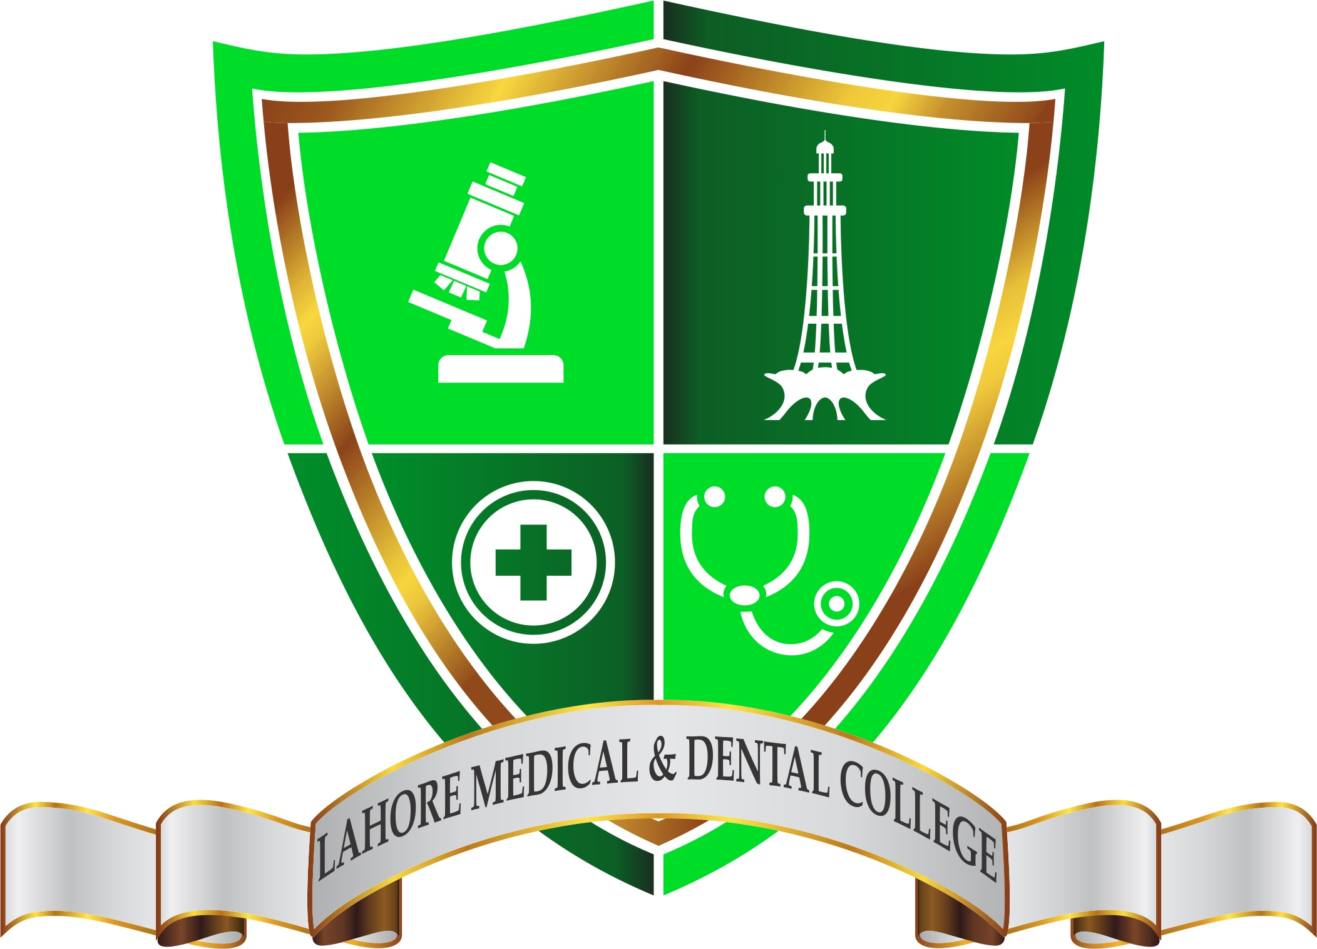
Lahore Medical & Dental College, Lahore
Department of Pharmacology
Study Guide
For
PHARMACOLOGY
(2nd Year B.D.S)

Contents:-
Sr. # | Contents | Page. No
1 | Introduction
2 | Learning Objects
3 | Syllabus (PMDC)
4 | Teaching & Learning Methodology
5 | Attendance Required
6 | Learning Resources
7 | Assessments Methods
8 | Exam Rules and Regulation
9 | Schedule / Planner / Timetable
10 | Organogram of Pharmacology

- Introduction:-

It is the science that deals with the origin, nature, chemistry, effects, and uses of drugs. it includes pharmacognosy, pharmacokinetics, pharmacodynamics, pharmacotherapeutics and toxicology.

Teaching in Year

2nd Year B.D.S

Duration of Course

One Year

- Learning Objectives: -

- GOAL: The broad goal of teaching under graduate students in pharmacology is to inculcate rational and scientific basis of therapeutics keeping in view of dental curriculum and Profession.

- OBJECTIVES:

a) KNOWLEDGE & UNDERSTANDING

At the end of the course the student shall be able to:
- Describe the pharmacokinetics and pharmacodynamics of essential and commonly used drugs in general and in dentistry in particular,
- List the indications, contraindications; interactions, and adverse reactions of commonly used drugs with reason,
- Tailor the use of appropriate drugs in disease with consideration to its cost, efficacy, safety for individual and mass therapy needs,
- Indicate special care in prescribing common and essential drugs in special medical situations such as pregnancy, lactation, old age, renal, hepatic damage and immunocompromised patients,
- Integrate the rational drug therapy in clinical pharmacology,
- Indicate the principles underlying the concepts of "Essential drugs".
b) SKILLS:
At the end of the course the student shall be able to:
- Prescribe drugs for common dental and medical ailments.
- To appreciate adverse reactions and drug interactions of commonly used drugs.
- Observe experiments designed for study of effects of drugs.
- Critically evaluate drug formulations and be able to interpret the clinical pharmacology of marketed preparations commonly used in dentistry.

c) INTEGRATION
Practical knowledge of use of drugs in clinical practice will be acquired through integrated teaching with clinical departments.
- Syllabus (PMDC)
Topic

General Pharmacology

Introduction

Routes of Administration
Transport across cell membrane
Absorption+ Bioavailability
Distribution
Biotransformation

Excretion, 1/2 Life, Kinetics

Pharmacodynamics
Dose response curve + Therapeutic Index
Drug allergy & Adverse effects
Drug dependence, addiction
Posology
Pharmacogenetics
Bioassay & Standardization
Locally acting drugs & Chelating agents
Disinfectants & Antiseptics + Phenol Chemo

Autonomic Nervous System
Introduction
Cholinergic Drugs
Anticholinergic Drugs
Muscle Relaxants
Ganglion Blockers
Catecholamines
Non-Catecholeamines
Beta Blockers
Alpha Blockers
Adrenergic Neuron Blockers

GIT Drugs
Bitters & Sialogogues
Emetics & Anti emetics
Purgatives & Laxatives
Treatment of P.U & Antacids
Anti diarrheals & Bacillaryt Dysentry

Respiratory System Drugs
Mucolytics, Expectorants & Antitussives
Bronchodilators & Treatment of Asthma

Cardiovascular System Drugs
Vasodilators: Direct & Ca⁺⁺ Channel Blockers
Antihypertensive drugs & Treatment of Hypertension
ACE Inhibitors
Antianginal Drugs
Treatment of CCF
Anti arrythmic Drugs
Diuretics

DRUGS ACTING ON BLOOD
Coagulants, Anti coagulants & Thrombolytic agents
Anti Platelets

Drugs acting on CNS
Introduction
General Anesthetics
Local Anesthetics
Anti Psychotic drugs
Antidepressants
Sedative & Hypnotics + Anti anxiety Drugs
Alcohol & Drug abuse
Trea arcotic Analgesics
Non-narcotic Analgesics
Treatment of Rheumatoid arthritis
Treatment of Epilepsy
CNS Stimulants & Xanthines
Treatment of gout
.

Drugs acting on Endocrine System
Pituitary hormones& Parathyroid drugs
Antithyroid
Corticosterroids
Antidiabetic Drugs(Insulin, Oral Hypoglycemic)

Therapeutics
Antibiotics: Introduction
Cell wall synthesis inhibitors
Penicillins & Cephalosporins
Bacitracin, Vancomycin, Monobactam,
carbapenems,aztreonam

Protein Synthesis Inhibitors
Aminoglycosides Macrolides
Tetracyclines & Chloramphenicol

Antifolates Drugs
Sulphonamides & Cotrimoxazole+
Trimethoprine and Pyrimethamine

DNA Synthesis Inhibitors
Urinary Antiseptics & Quinolone derivatives
Anti Cancer Drugs
Anti Viral Drugs
Antifungal Drugs
Anti TB & Leprosy drugs
Antimalarial
Anti amoebic Drugs
Anthelmintics

Dental Pharmacology:-
Antimicrobial agents used in Dentistry
Analgesic used in Dentistry
Antiseptics and Disinfectants
Agents used for the prevention of dental caries
Agents used for maintenance of oral hygiene
Dentin desensitizing agent
Agent used in root canal therapy
Local anesthetics used in dentistry

Practical Pharmacology:-
Measurments System
Common drug Preprations:-
Lotion
Ointment
Solution
Emulsion
Powder
Mixtures
Suspensions

- Teaching & Learning Methodologies

- Interactive Lectures
- Tutorials
- Practicals
- Small Group Discussions
- Batch Wise Viva Voce
- Monthly bases tests (MCQ’s and SEQ’s)
- Long Tutorial Sessions
- Topic Wise Practice Test
- Using Latest Techniques of electronic facilities like Audio Visual and Multimedia
- Recommended E. Books

- Attendance Required

- 75% Attendance is mandatory in (Lectures, Practical and Tutorials)

- A minimum 75% Attendance is required for eligibility to appear in Annual Examination according to University of Health Sciences, Lahore

- Attendance will be marked through the Bio- Metric Attendance Systems (thumb Impression) and also record in Attendance Registers.

- Absences due to Sickness/ Illness must be certified by a Medical Officer and approved by Principal and Head of Department also.

- Learning Resources
Recommended Books:-
- Goodman & Gilman’s - The Pharmacological Basis of Therapeutics
- Basic & Clinical Pharmacology by Bertram G, Katzung
- Clinical Pharmacology by DR Lawrence, PN Bennett & MJ Brown
- Essentials of Medical Pharmacology by K.D. Tripathi
- Lippincott Illustrated Review Pharmacology
- Lecture Notes on Drugs for Dental Students by Wilkin & Davidson
- Clinical Pharmacology in Dental Practice by S V Holroyd
- Clinical Dental Pharmacology Kamran Ali

- Technologies to be Used: -
- Text Books are the Most Important source to learn for this Subject
- Hand Outs (by Senior Faculty Members)
- E. Books (Available)
- Multimedia (Power Point)
- Tables of Drugs Chart
- Discussions
- Viva Voce type Practice
- Departmental Library

- Assessments Methods

Formative:-

- MCQ’s and SEQ’s type Test will be held at the end of the every topic.
- Viva Voce will be held at the end of every major topic.
- Assignments given, checked and marked for 10 % Internal Assessment marks
- Summer Vacation work (assignments type)

- Exam Rules and Regulation
Examination will be held at the end of the session of the year
Marks Distribution According to University of Health Sciences Rules and Regulation:-

Total Marks of the subject in Professional examination----200 Marks
Theory Examination:
- 45 Multiple Choice Questions (1 Mark for Each Question) -------------– 45 Marks
- 15 Short Essay Questions (3 marks for Each Question) ----------------45 Marks
- Internal Assessment ---10 Marks
Total Marks 100 Marks
Oral//Practical & Viva Voce Examination:
Viva Voce Examination:-

- Viva Voce will be held after Theory Examination
- Viva Voce (Internal Examiner): 30 Marks and 05 Marks for Note Book ---35 Marks
- Viva Voce (External Examiner): 30 Marks---------------------------------------30 Marks
OSPE Examination: -
- 05 Observed and non-Observed Stations (Each Station having 03 Marks)-- 15 Marks
- Pharmacy Practical: ---10 Marks
- Internal Assessment: ----10 Marks
Total Marks: 100 Marks

- Schedule / Planner / Timetable
Schedule / Planner for the Year 2018-2019
Topic Teacher No of Lect

General Pharmacology

Introduction Dr. Ajaz Fatima 01

Routes of Administration Dr. Ajaz Fatima 02
Absorption+ Bioavailability Dr.Shazia Asim 01
Distribution Dr. Ajaz Fatima 02
Biotransformation Dr. Shazia Asim 02

Excretion, 1/2 Life, Kinetics Dr. Asia Firdous 02

Pharmacodynamics Dr. Awais 04
Dose response curve + Therapeutic Index Dr. Awais
Drug allergy & Adverse effects Dr.Awais Qarni 02
Drug dependence, addiction Dr.Awais Qarni 02
Posology Dr. Wardah 01
Pharmacogenetics Dr. Ajaz Fatima 01
Bioassay & Standardisation Dr.Wardah 01
Locally acting drugs & Chelating agents Dr. Awais 02
Disinfectants & Antiseptics + Phenol Dr. Awais 02

Autonomic Nervous System
Introduction Dr. Asia Firdous 01
Cholinergic Drugs Dr. Asia Firdous 01
Anticholinergic Dr. Ajaz Fatima 02
Muscle Relaxants Dr. Awais Qarni 01
Ganglion Blockers Dr. Wardah 01
Catecholamines Dr. Ajaz Fatima 03
Non-Catecholeamines Dr. Asia Firdous 02
Beta Blockers Dr. Asia Firdous 02
Alpha Blockers Dr. Asia Firdous 01
Adrenergic Neuron Blockers Dr.Wardah 02
Ergot Alkaloids & Bromocryptine Dr. Wardah 01
Centrally acting sympathoplegics Dr. Wardah 01

GIT Drugs
Emetics & Anti emetics Dr. Asia Firdous 01
Purgatives & Laxatives Dr. Wardah 01
Treatment of P.U & Antacids Dr. Wardah 03

Cardiovascular System Drugs
Vasodilators: Direct & Ca⁺⁺ Channel Blockers Dr. Ajaz Fatima 03
Antihypertensive drugs & Treatment of Hypertension Dr. Ajaz Fatima 02
ACE Inhibitors Dr. Ajaz Fatima 02
Antianginal Drugs Dr. Awais Qarni 03
Treatment of CCF Dr. Ajaz FAtima 03
Anti arrythmic Drugs Dr. Asia Firdous 03
Diuretics Dr. Wardah 02

DRUGS ACTING ONBLOOD
Antihyperlipidemic Drugs Dr. Asia Firdous 01
Coagulants, Anti coagulants & Thrombolytic agents Dr.Awais 02
Anti Platelets Dr. Awais Qarni 01

Autocoids:-
Histamine & Anti histamine Dr. AsiaFirdous 02
Prostaglandins & Serotonins Dr. Wardah 02

Drugs acting on CNS
Introduction Dr. Ajaz Fatima 01
General Anesthetics Dr. Ajaz Fatima 03
Local Anesthetics Dr. Wardah 02
Anti Psychotic drugs Dr. Awais 02
Antidepressants Dr. Ajaz Fatima 02
Antimaniacs Dr. Asia Firdous 01
Sedative & Hypnotics + Anti anxiety Drugs Dr. Ajaz Fatima 03
Alcohol & Drug abuse Dr. Awais Qarni 02
Treatment of Epilepsy Dr. Asia Firdous 02
Narcotic Analgesics Dr. Asia Firdous 02
Non-narcotic Analgesics Dr. Ajaz Fatima 03
Treatment of Rheumatoid arthritis Dr. Ajaz Fatima 01
Treatment of gout Dr. Wardah 01

Drugs acting on Endocrine System
Pituitary hormones& Parathyroid drugs Dr. Wardah Siddique 01
Antithyroid Dr. Wardah 02
Corticosterroids Dr. Ajaz Fatima 02
Antidiabetic Drugs Dr. Awais Qarni 03

Therapeutics
Antibiotics: Introduction Dr. Asia Firdous 01

Cell wall synthesis inhibitors
Penicillins & Cephalosporins Dr. Wardah 02
Bacitracin, Vancomycin, Monobactam,
carbapenems,aztreonam Dr. Wardah 01

Protein Synthesis Inhibitors
Aminoglycosides Macrolides Dr. Asia Firdous 02
Tetracyclines & Chloramphenicol Dr. Asia Firdous 01

Antifolates Drugs
Sulphonamides & Cotrimoxazole+ Dr. Ajaz Fatima 02
Trimethoprine and Pyrimethamine

DNA Synthesis Inhibitors
Urinary Antiseptics & Quinolone derivatives Dr. Ajaz Fatima 01
Anti Cancer Drugs Dr. Wardah 03
Anti Viral Drugs Dr. Ajaz Fatima 02
Antifungal Drugs Dr. Asia Firdous 01
Anti TB & Leprosy drugs Dr. Awais 02
Antimalarial Dr. Asia Firdous 02
Anti amoebic Drugs Dr. Ajaz Fatima 02
Drug Interactions Dr. Wardah 01

Time Table for 2nd Year B.D.S (Weekly Schedule)
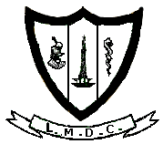Lahore Medical & Dental College, Lahore.
2nd Year BDS
Weekly Lectures Schedule
Date: from: to:
Day | TIME | TOPIC | TEACHER
Monday | 09:30am  to  10:15 am
Tuesday | 11:30am  To  12:15pm
Wednesday | 09:30am  To  10:15am
Friday | 08:15am  To  09:00am

Weekly Practical Schedule
Time: 07:30AM to 09:30AM
Day | Batch | Practical Topic | Teacher
Monday | Batch B
Tuesday | Batch A
Wednesday | Batch B
Thursday | Batch A

Teaching Hours:-

For 2nd Year B.D.S
For Lectures: 108 hours
For Practical & Tutorials: 288 hours

- ORGANOGRAM OF PHARMACOLOGY DEPARTMENT
Prof. Dr. Ajaz Fatima
MBBS, M Phil
Head of department of Pharmacology
- Dr. Ajaz Fatima
MBBS, M.Phil Professor (H.O.D)

Dr. Shazia Asim
MBBS, M.Phil Professor

Dr. Wardah Siddique
MBBS, M.Phil,Assisstant Professor

Dr. Asia Firdous
MBBS, M.Phil Assisstant Professor

Dr. Ghulam Awais Qarni
MBBS, M.Phil (part 1) Senior Lecturer

Dr. Rubina Raza (MBBS)
Dr. Bushra Haider (MBBS)
Dr. Humaira Mushtaq (MBBS)

- Khalid Masood(computer operator)
- Saif ul Mulook (lab technician)
- Mohammad Amin(lab assistant)
- Jan Mohammad (office boy)
- Mohammad Kashif (store keeper)

